[Each use case in the project has a unique identifier. Typically this reference is held in a database and used to cross-reference the use case against other requirements, such as those that might arise out of test plan.]
[The name is an active verb phrase, the goal of the primary actor, and something that the system can deliver to the primary actor.
e.g. Purchase Item, Withdraw Cash, Transfer Funds, Maintain Curve Definition…]

Diagramas de Seqüência

Fluxo Principal - Caso de Uso Logar Sistema

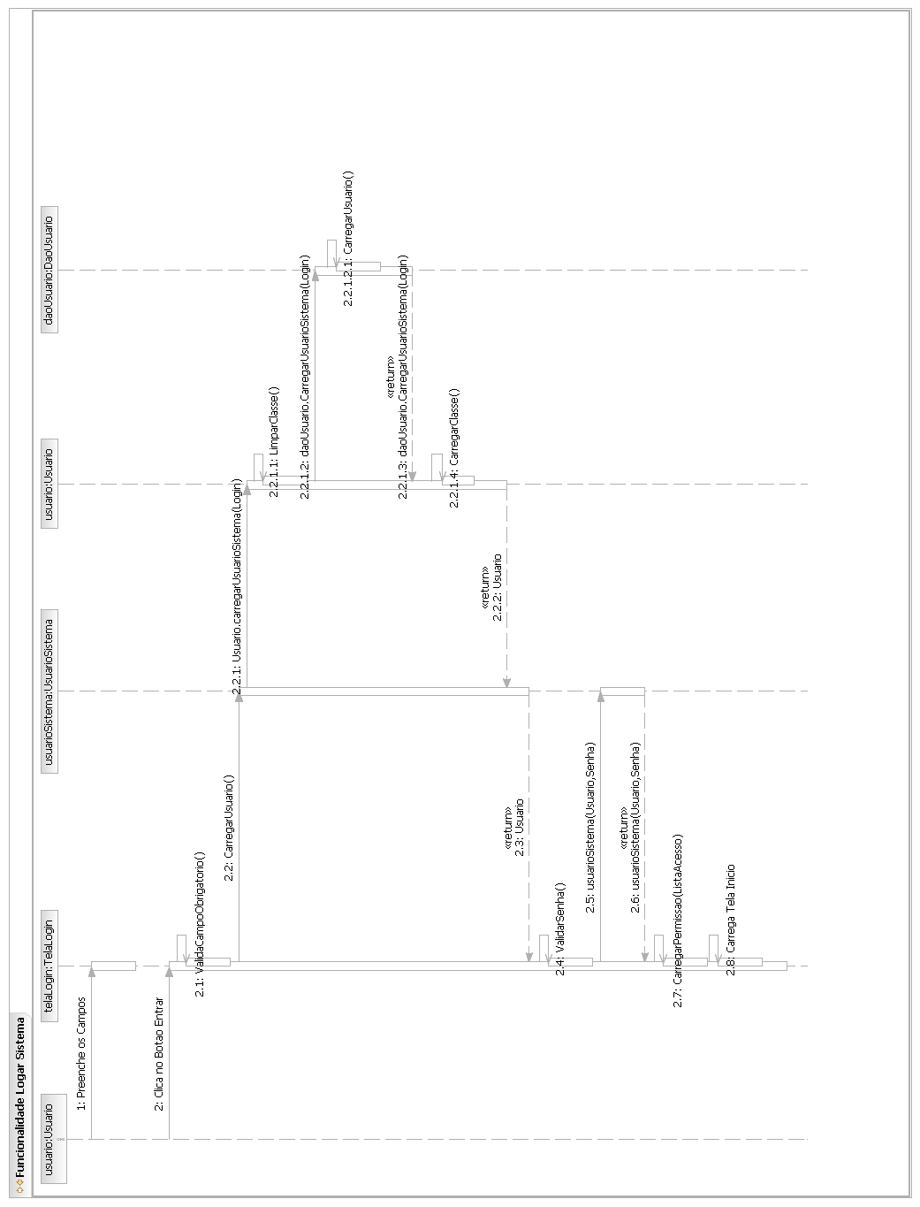

Fluxo Principal - Caso de Uso Gerar Cardápio
[Each use case in the project has a unique identifier. Typically this reference is held in a database and used to cross-reference the use case against other requirements, such as those that might arise out of test plan.]
[The name is an active verb phrase, the goal of the primary actor, and something that the system can deliver to the primary actor.
e.g. Purchase Item, Withdraw Cash, Transfer Funds, Maintain Curve Definition…]

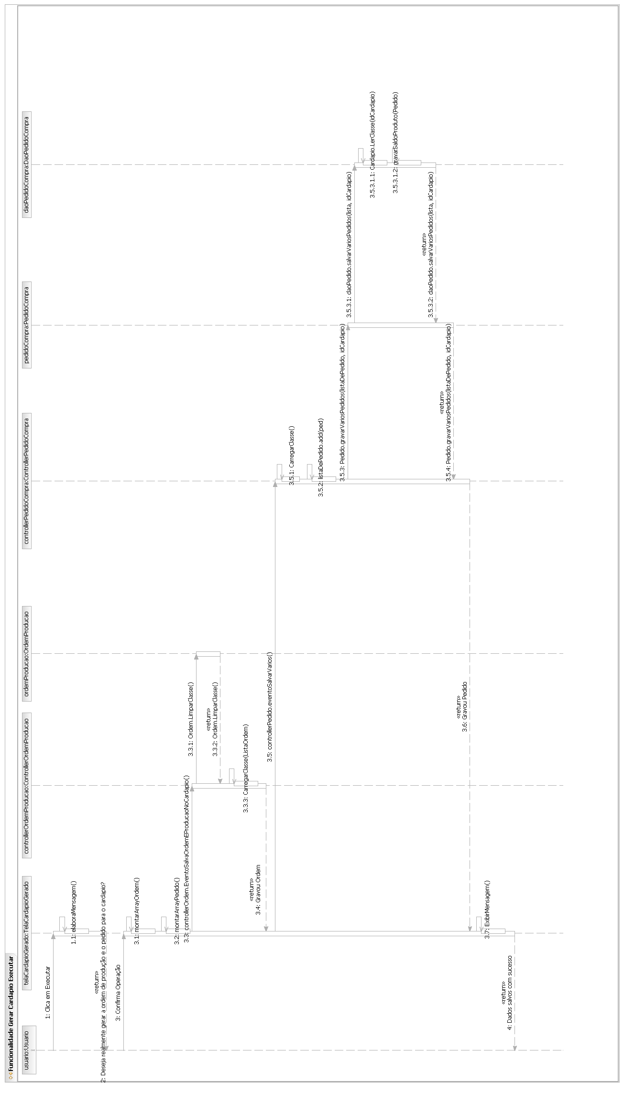
Fluxo Principal - Caso de Uso Avaliação do Pedido
[Each use case in the project has a unique identifier. Typically this reference is held in a database and used to cross-reference the use case against other requirements, such as those that might arise out of test plan.]
[The name is an active verb phrase, the goal of the primary actor, and something that the system can deliver to the primary actor.
e.g. Purchase Item, Withdraw Cash, Transfer Funds, Maintain Curve Definition…]

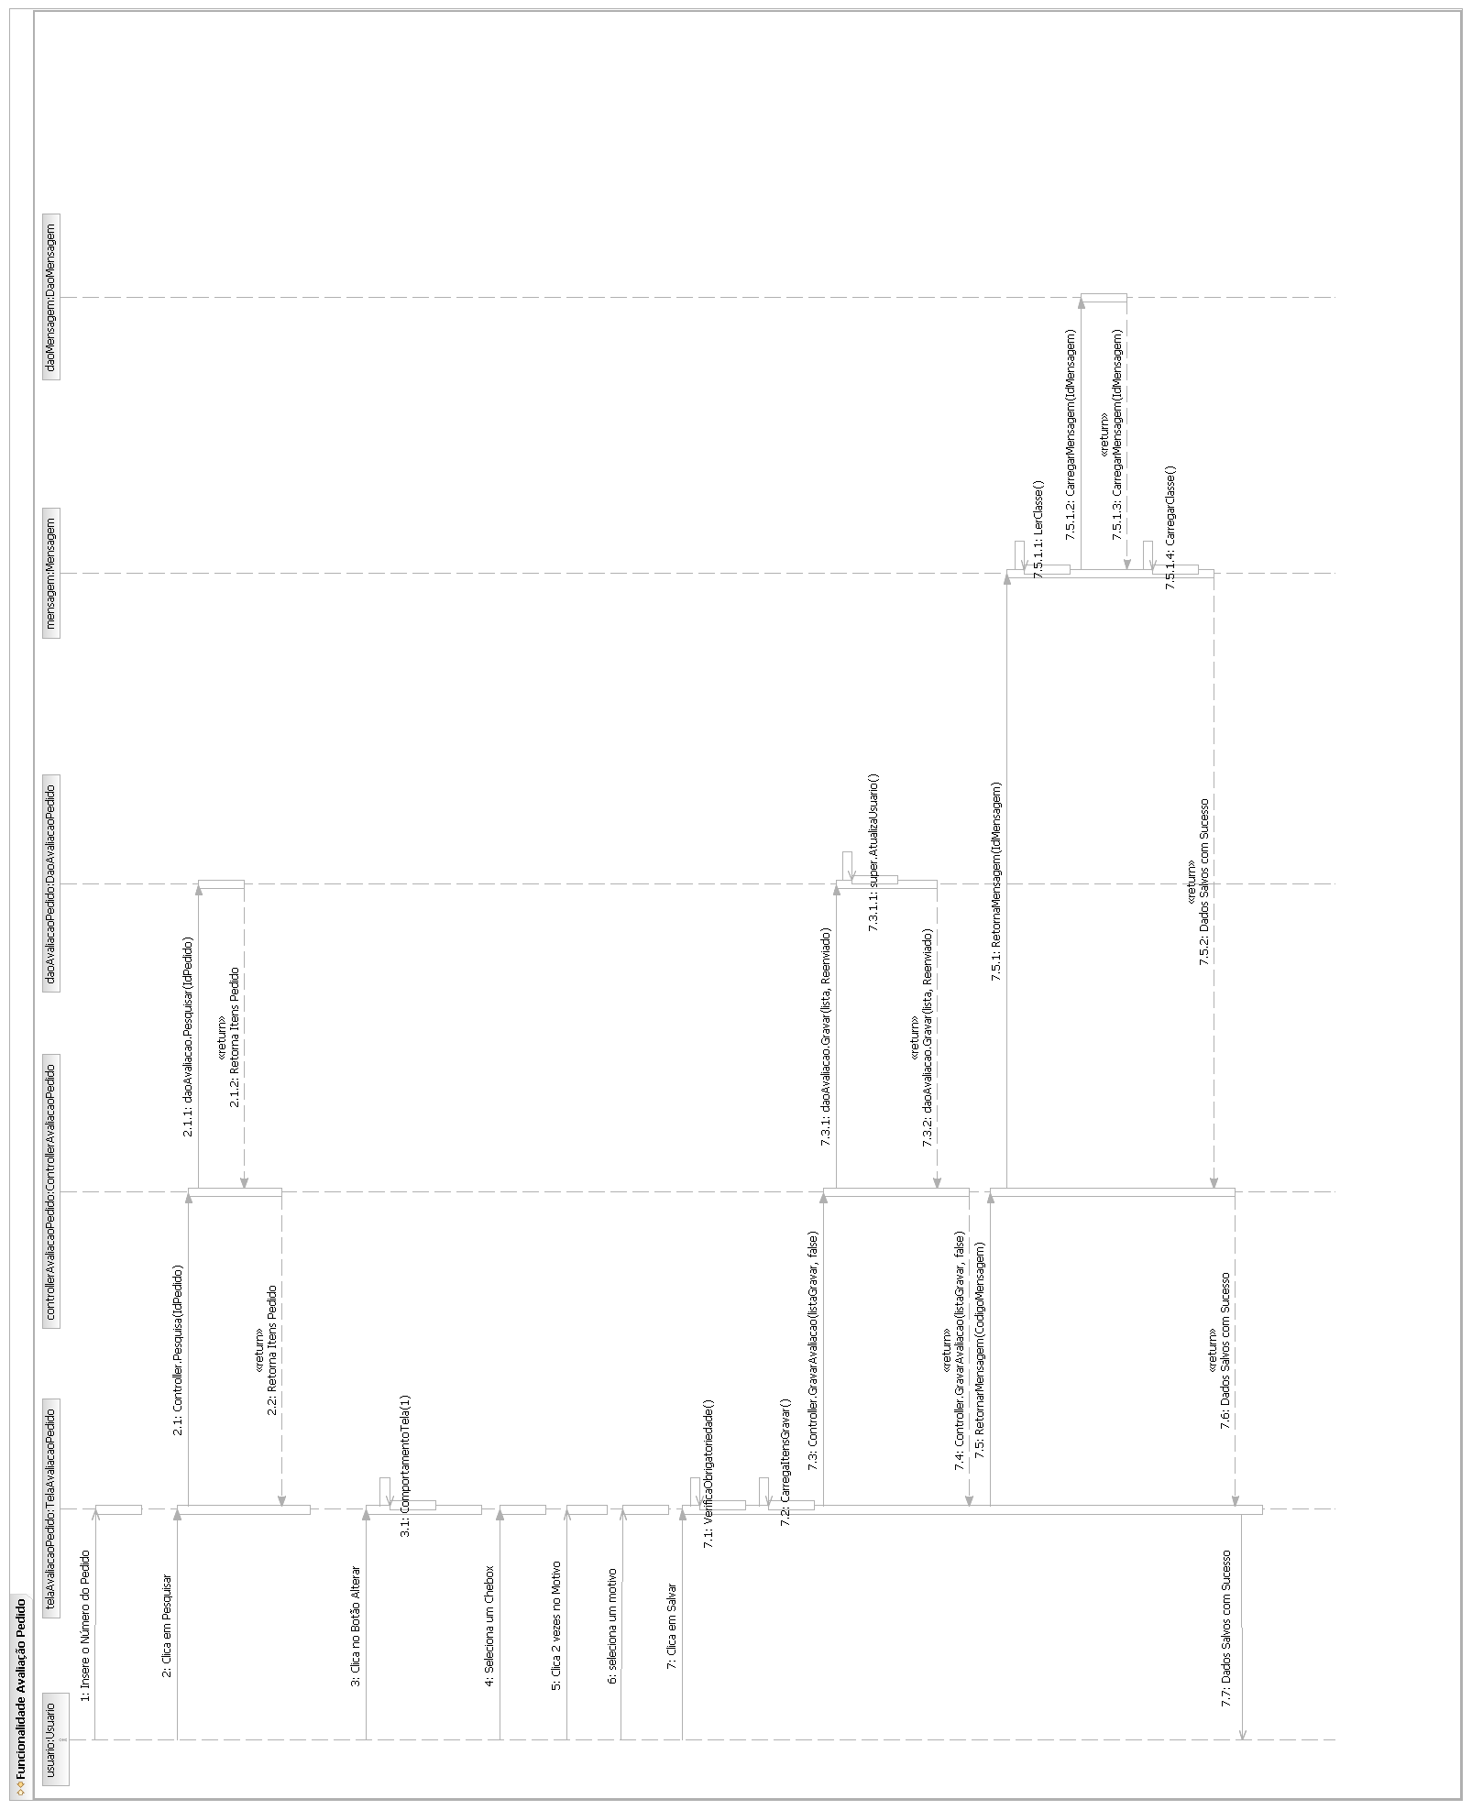
Fluxo Principal - Pesquisar Saldo

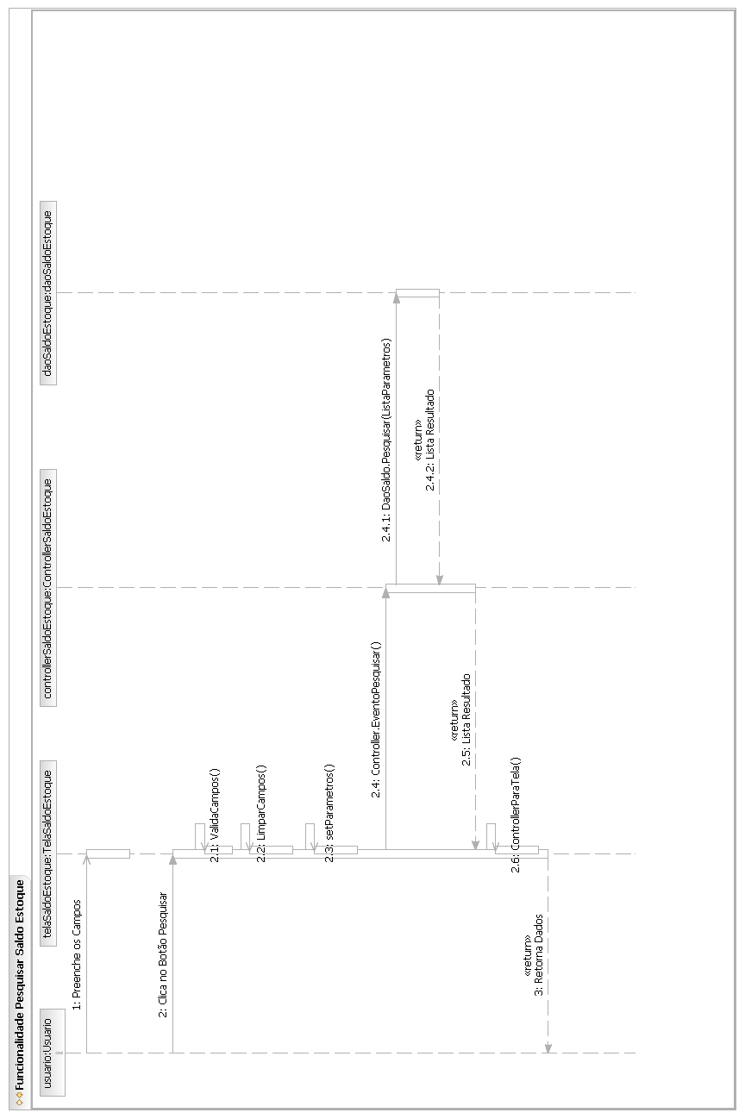

Fluxo Principal - Caso de Uso Importação

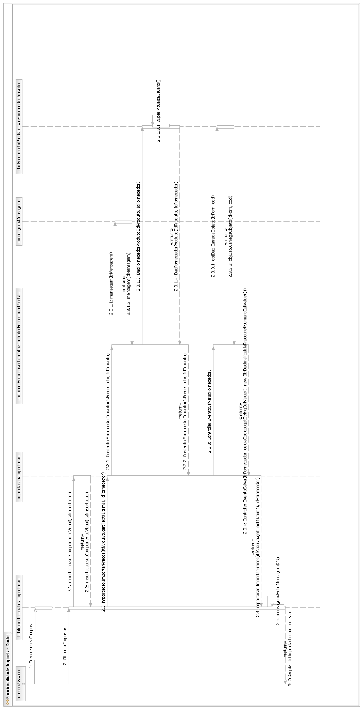

Fluxo Principal - Caso de Uso Configurações
[Each use case in the project has a unique identifier. Typically this reference is held in a database and used to cross-reference the use case against other requirements, such as those that might arise out of test plan.]
[The name is an active verb phrase, the goal of the primary actor, and something that the system can deliver to the primary actor.
e.g. Purchase Item, Withdraw Cash, Transfer Funds, Maintain Curve Definition…]

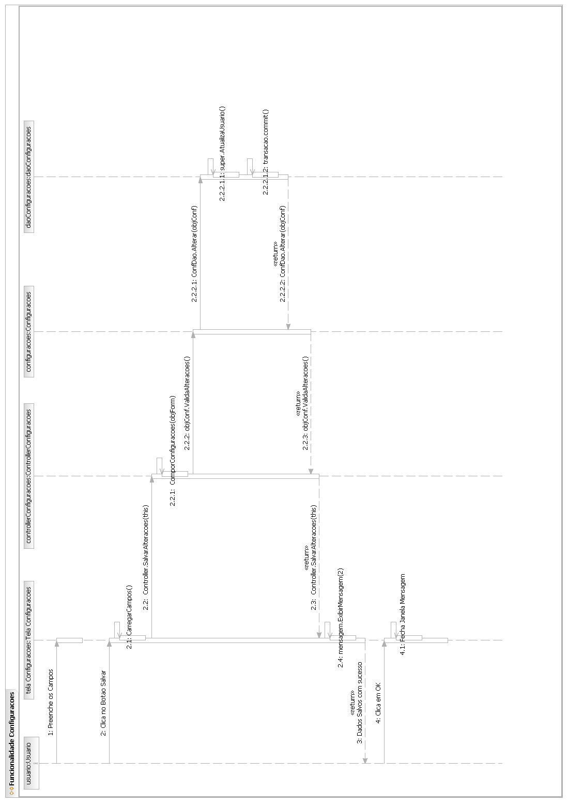

Fluxo Principal - Caso de Uso Cadastrar Banco
[Each use case in the project has a unique identifier. Typically this reference is held in a database and used to cross-reference the use case against other requirements, such as those that might arise out of test plan.]
[The name is an active verb phrase, the goal of the primary actor, and something that the system can deliver to the primary actor.
e.g. Purchase Item, Withdraw Cash, Transfer Funds, Maintain Curve Definition…]

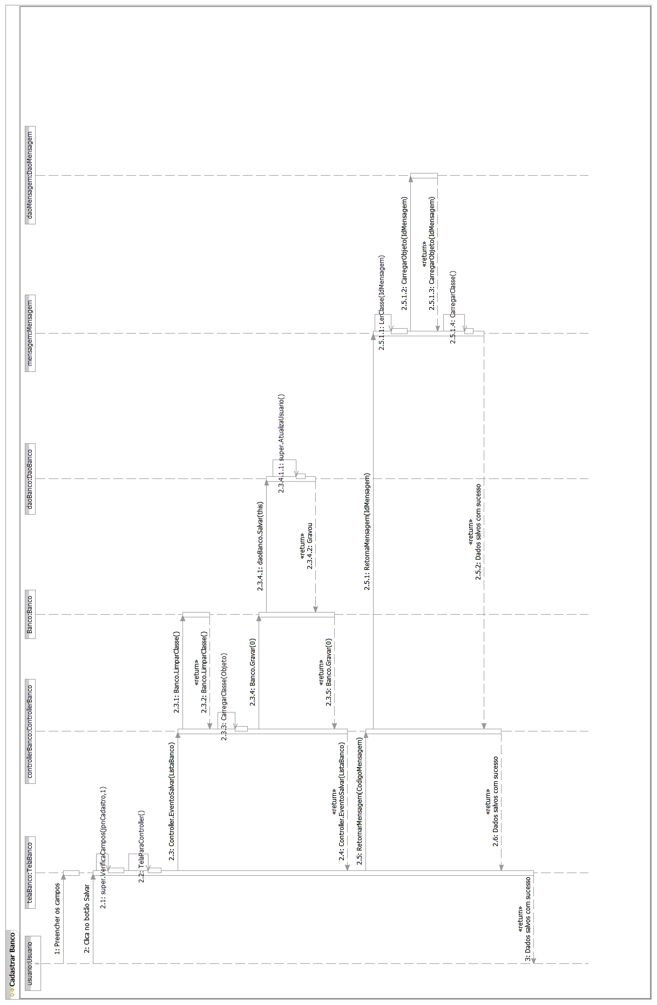
Fluxo Principal - Caso de Uso Cadastrar Botão
[Each use case in the project has a unique identifier. Typically this reference is held in a database and used to cross-reference the use case against other requirements, such as those that might arise out of test plan.]
[The name is an active verb phrase, the goal of the primary actor, and something that the system can deliver to the primary actor.
e.g. Purchase Item, Withdraw Cash, Transfer Funds, Maintain Curve Definition…]

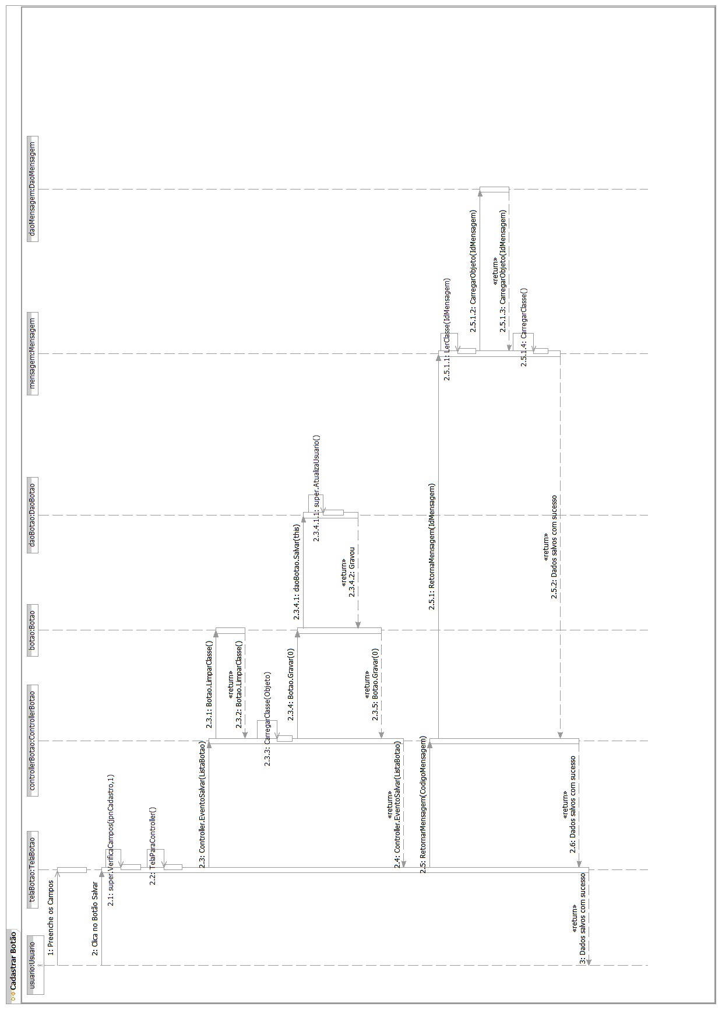

Fluxo Principal – Cadastrar Cardápio

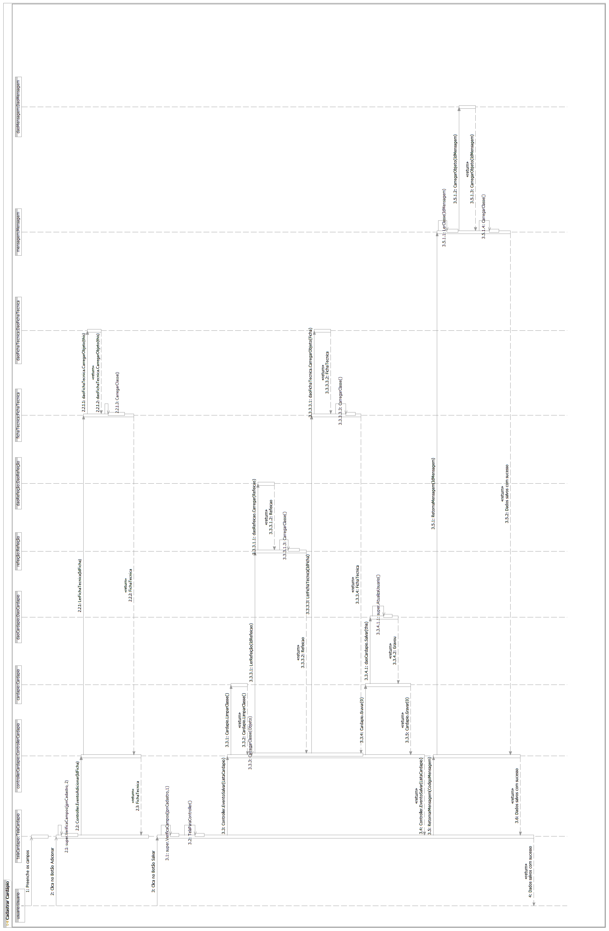
Fluxo Principal - Caso de Uso Cadastrar Cargo

[Each use case in the project has a unique identifier. Typically this reference is held in a database and used to cross-reference the use case against other requirements, such as those that might arise out of test plan.]
[The name is an active verb phrase, the goal of the primary actor, and something that the system can deliver to the primary actor.
e.g. Purchase Item, Withdraw Cash, Transfer Funds, Maintain Curve Definition…]
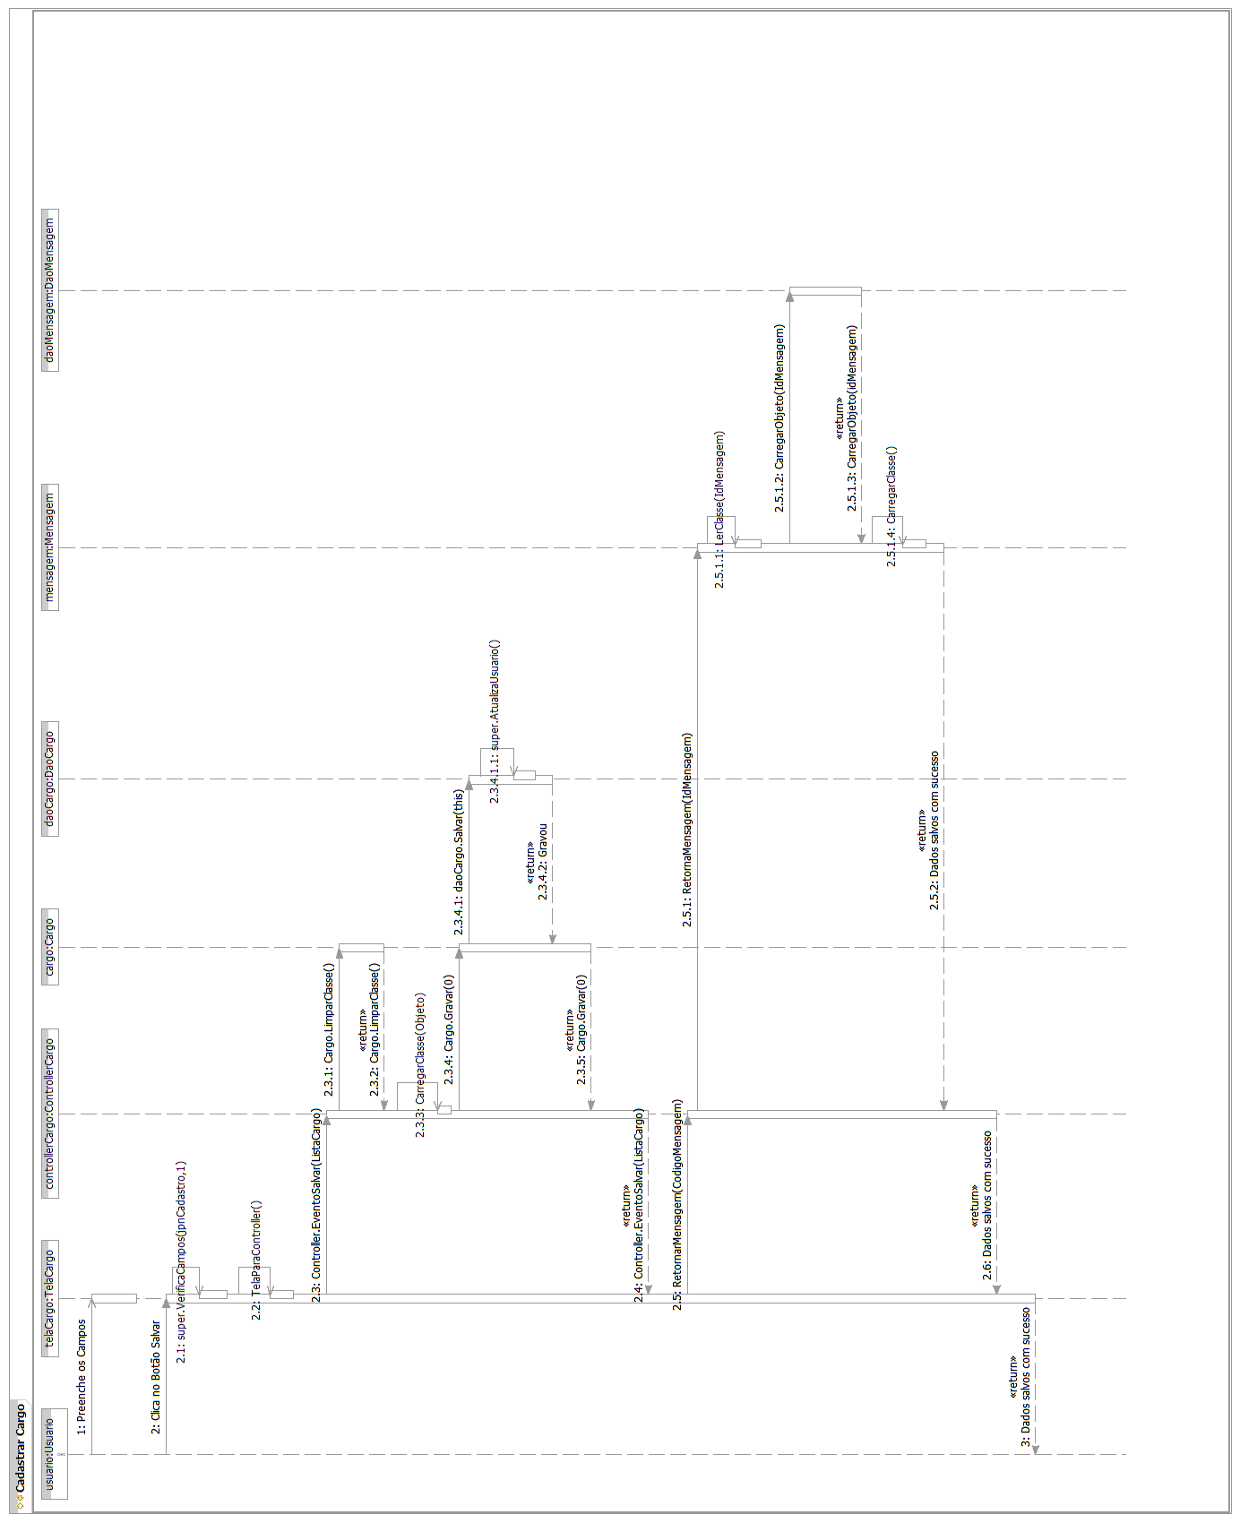
Fluxo Principal – Caso de Uso Cadastrar Composição Centesimal
[Each use case in the project has a unique identifier. Typically this reference is held in a database and used to cross-reference the use case against other requirements, such as those that might arise out of test plan.]
[The name is an active verb phrase, the goal of the primary actor, and something that the system can deliver to the primary actor.
e.g. Purchase Item, Withdraw Cash, Transfer Funds, Maintain Curve Definition…]

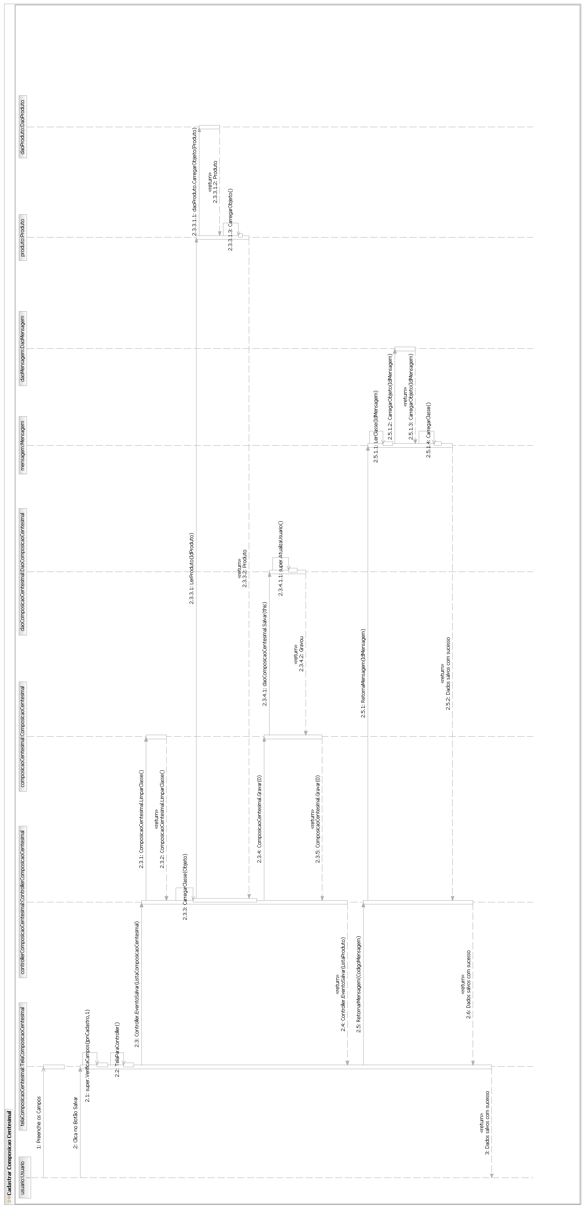

Fluxo Principal – Caso de Uso Cadastrar Contato do Fornecedor

[Each use case in the project has a unique identifier. Typically this reference is held in a database and used to cross-reference the use case against other requirements, such as those that might arise out of test plan.]
[The name is an active verb phrase, the goal of the primary actor, and something that the system can deliver to the primary actor.
e.g. Purchase Item, Withdraw Cash, Transfer Funds, Maintain Curve Definition…]
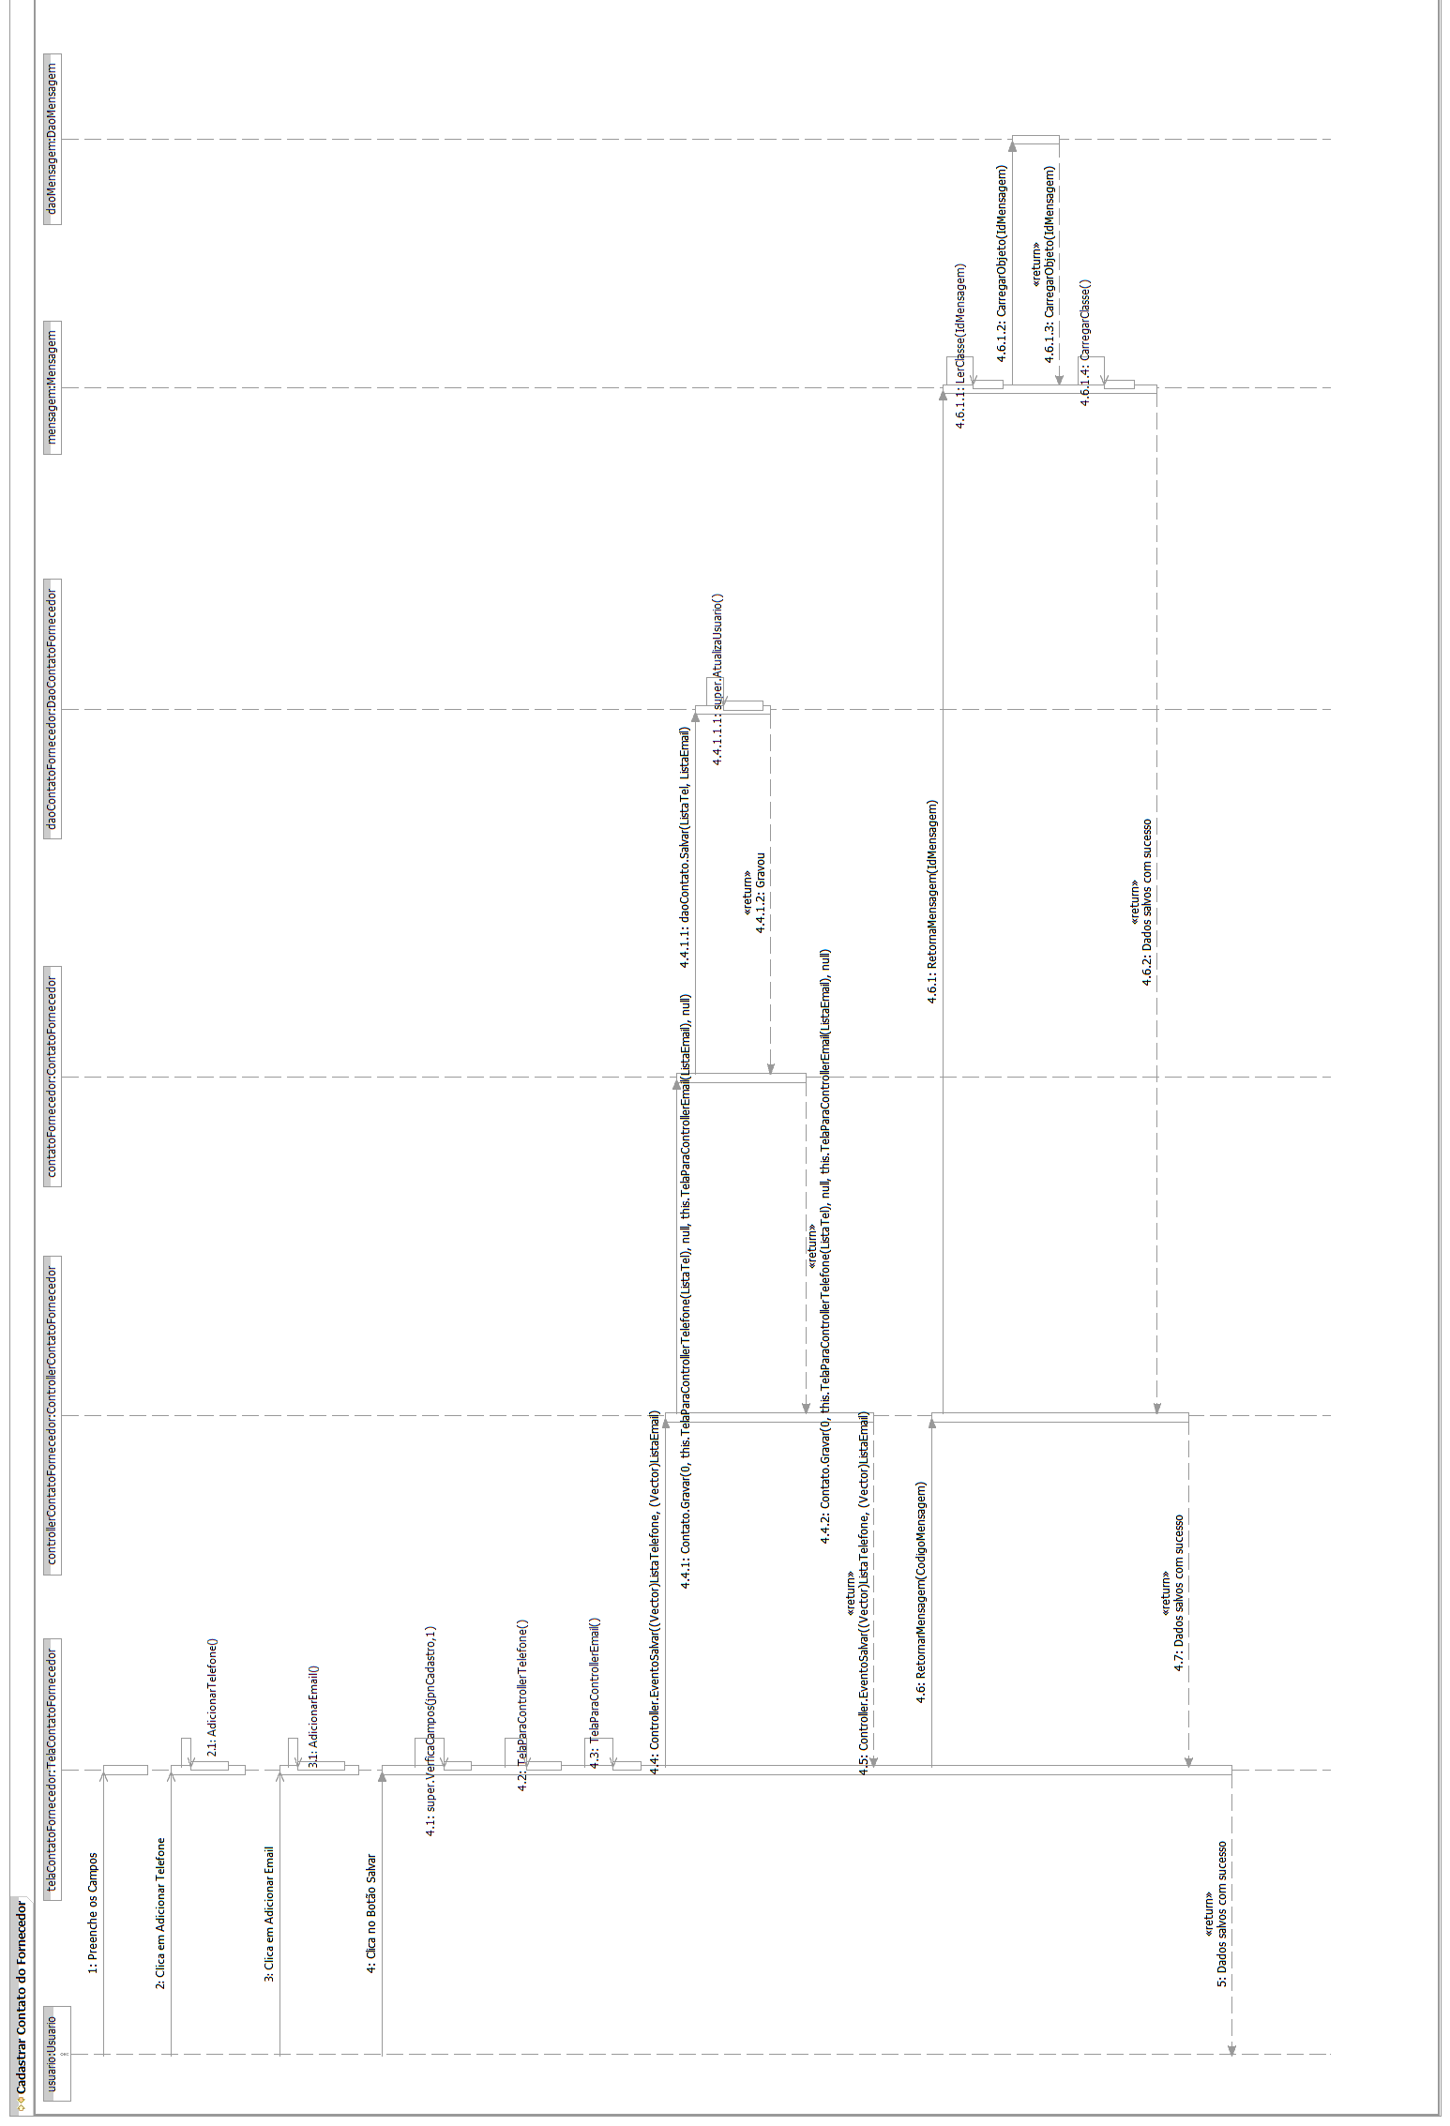

Fluxo Principal - Caso de Uso Cadastrar Movimentação do Estoque
[Each use case in the project has a unique identifier. Typically this reference is held in a database and used to cross-reference the use case against other requirements, such as those that might arise out of test plan.]
[The name is an active verb phrase, the goal of the primary actor, and something that the system can deliver to the primary actor.
e.g. Purchase Item, Withdraw Cash, Transfer Funds, Maintain Curve Definition…]
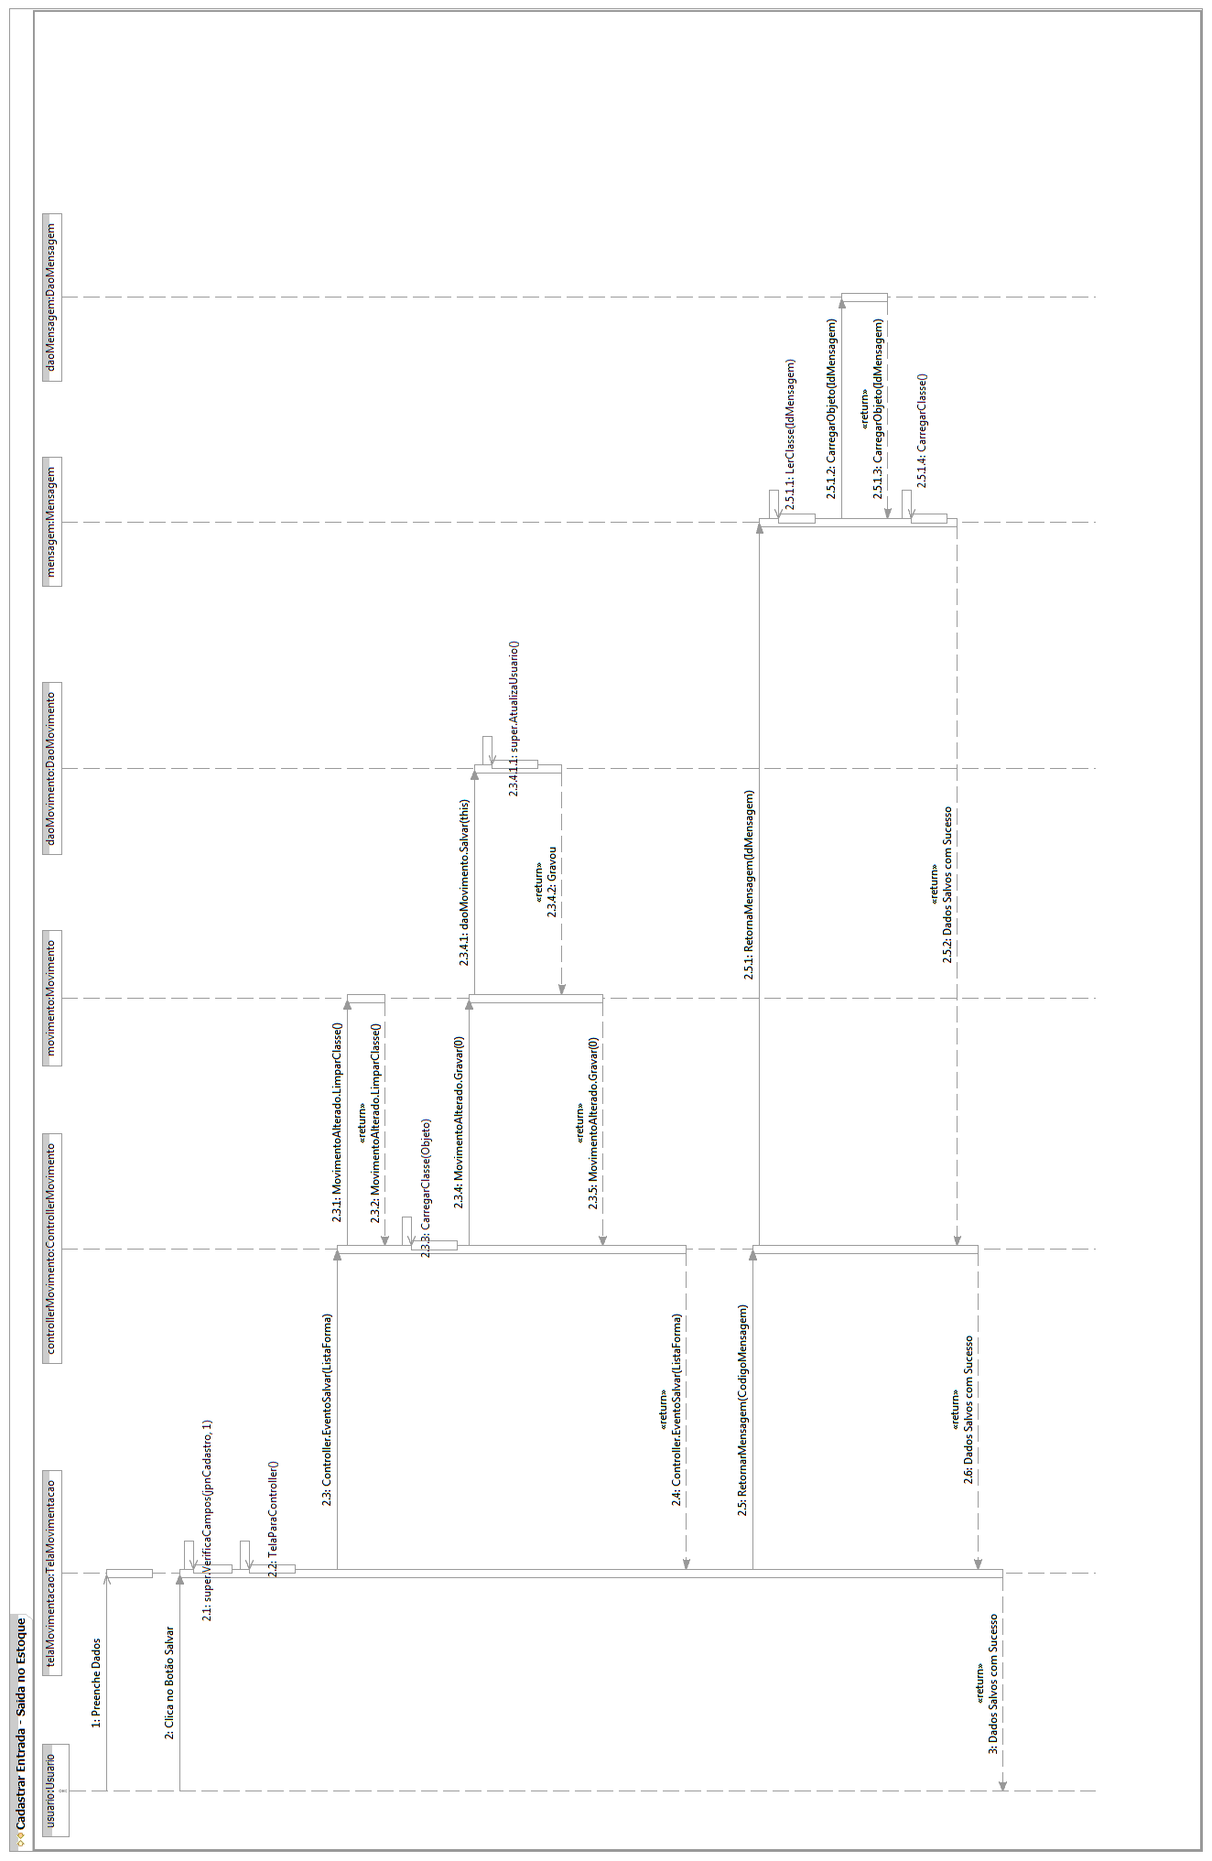
Fluxo Principal – Caso de Uso Cadastrar Ficha Técnica
[Each use case in the project has a unique identifier. Typically this reference is held in a database and used to cross-reference the use case against other requirements, such as those that might arise out of test plan.]
[The name is an active verb phrase, the goal of the primary actor, and something that the system can deliver to the primary actor.
e.g. Purchase Item, Withdraw Cash, Transfer Funds, Maintain Curve Definition…]

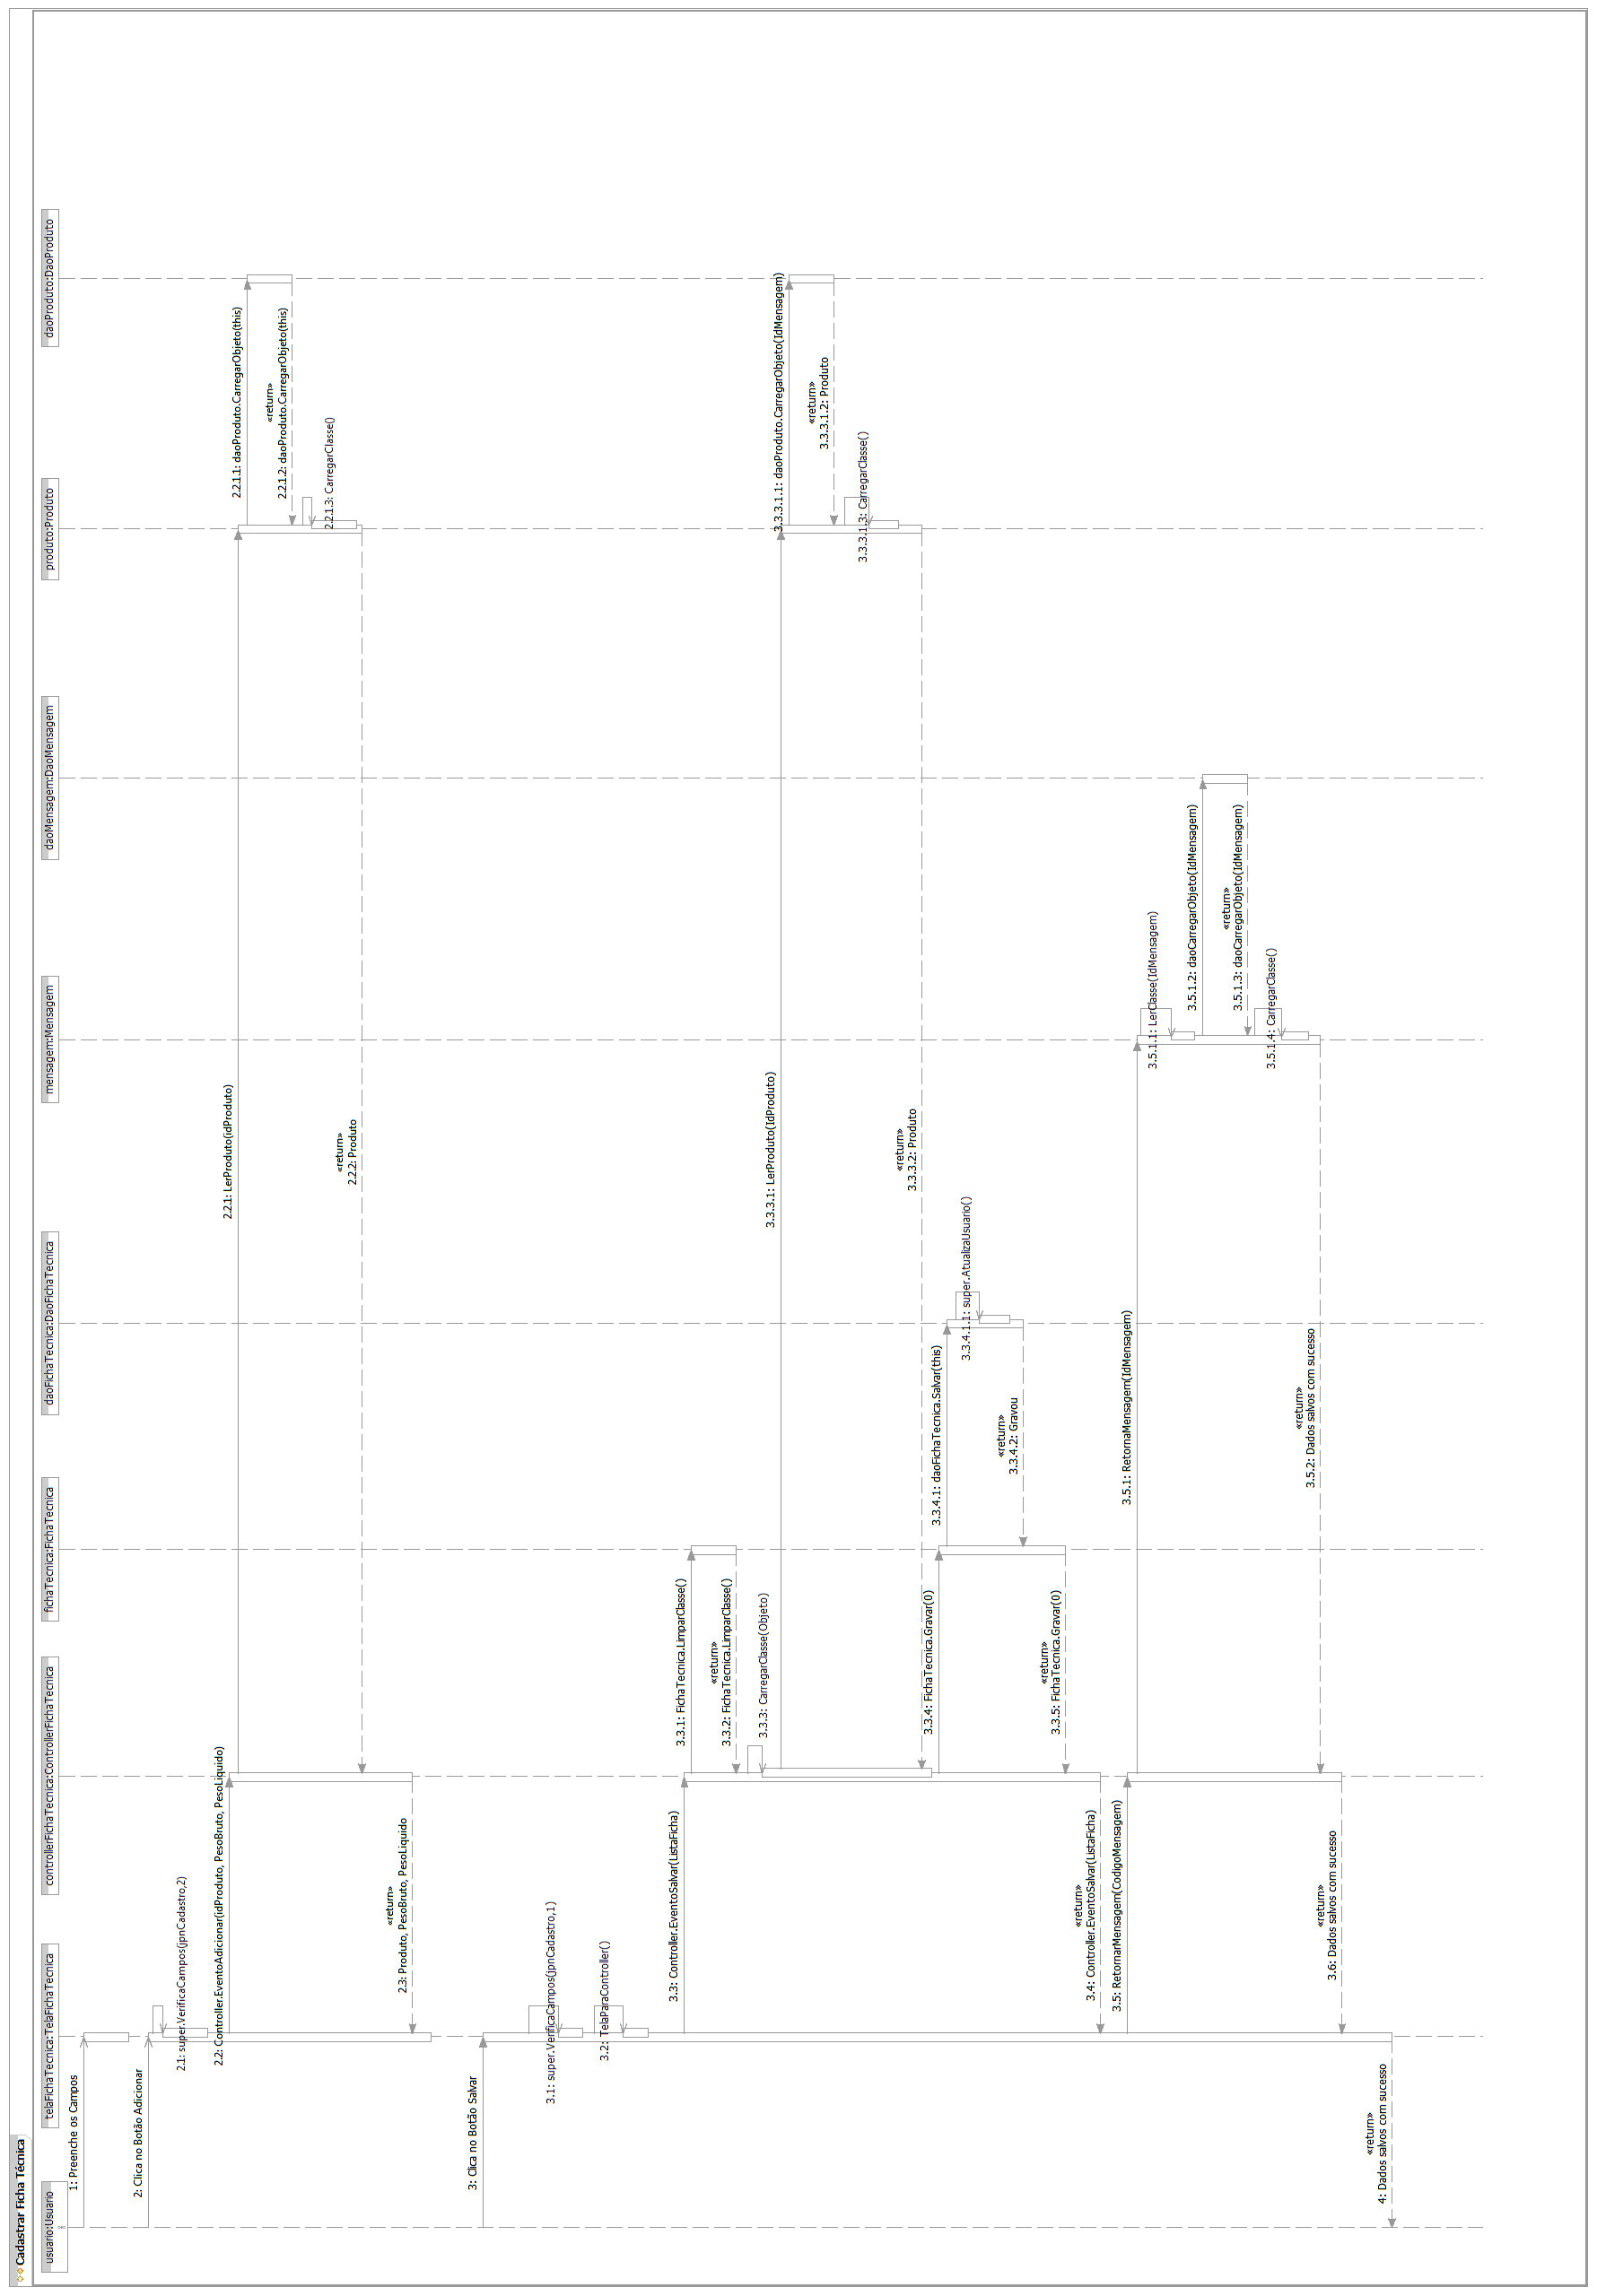

Fluxo Principal - Caso de Uso Cadastrar Forma de Pagamento
[Each use case in the project has a unique identifier. Typically this reference is held in a database and used to cross-reference the use case against other requirements, such as those that might arise out of test plan.]
[The name is an active verb phrase, the goal of the primary actor, and something that the system can deliver to the primary actor.
e.g. Purchase Item, Withdraw Cash, Transfer Funds, Maintain Curve Definition…]

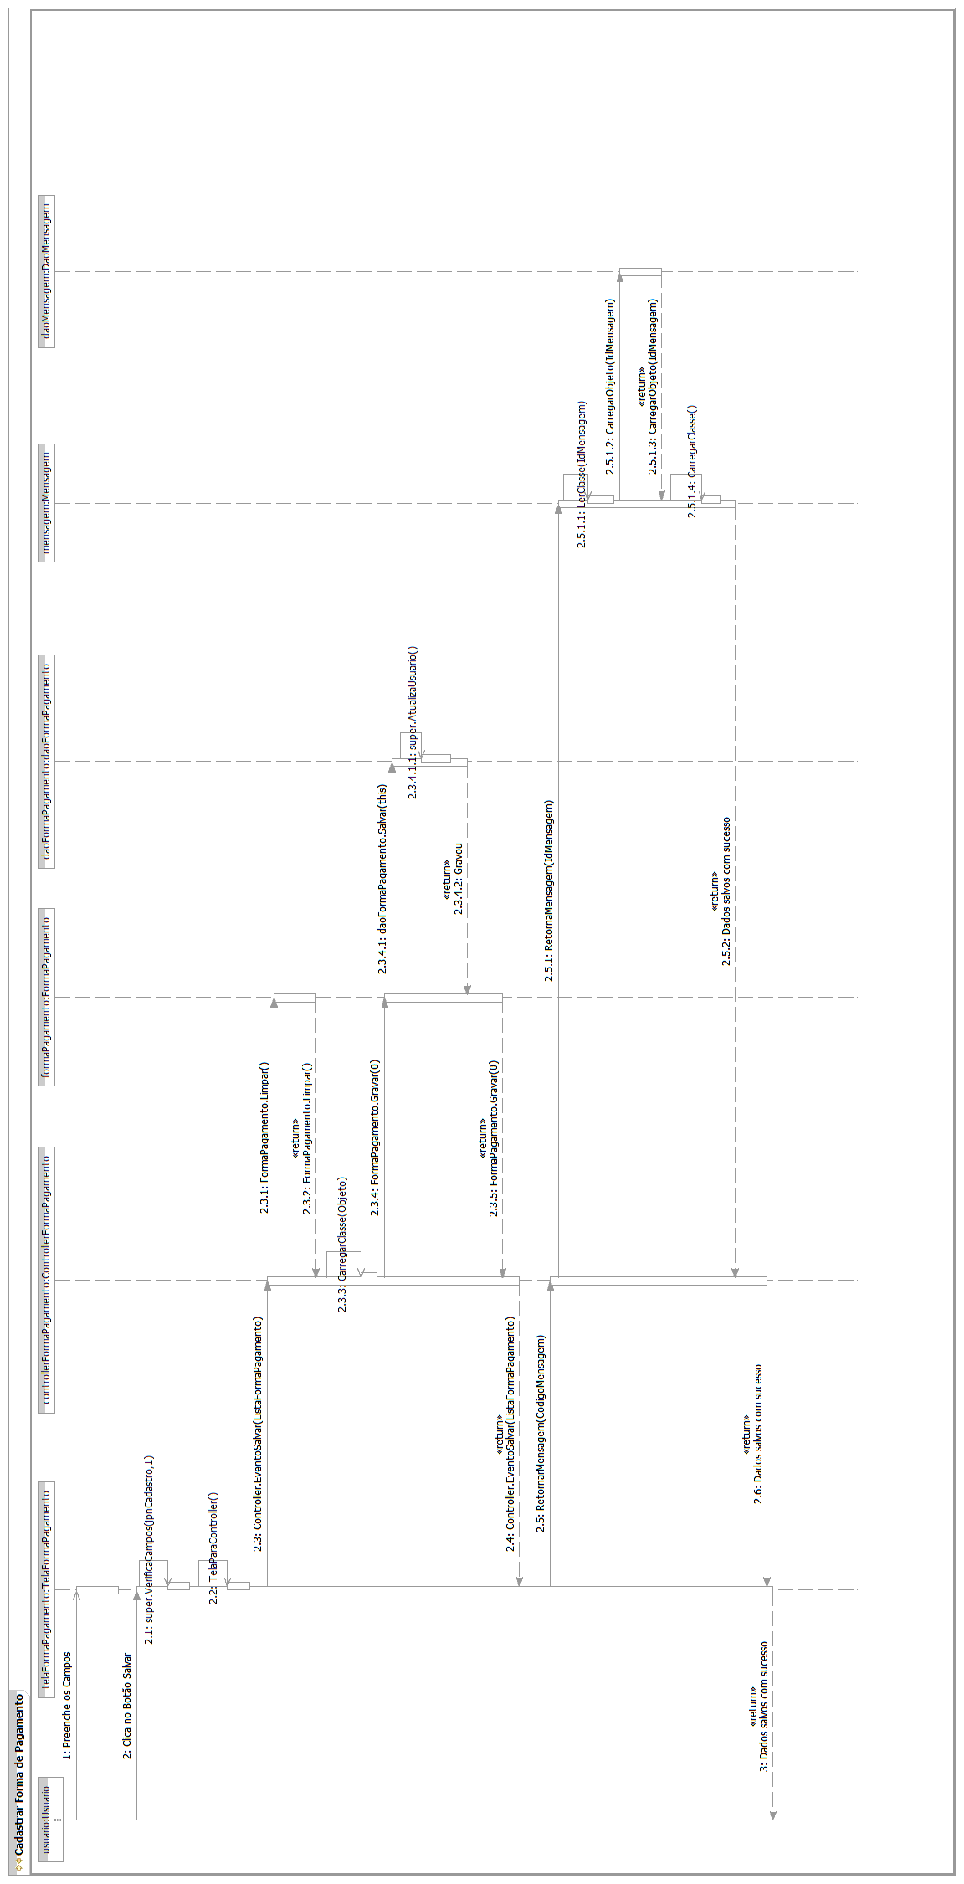

Fluxo Principal - Caso de Uso Cadastrar Forma de Pagamento do Fornecedor
[Each use case in the project has a unique identifier. Typically this reference is held in a database and used to cross-reference the use case against other requirements, such as those that might arise out of test plan.]
[The name is an active verb phrase, the goal of the primary actor, and something that the system can deliver to the primary actor.
e.g. Purchase Item, Withdraw Cash, Transfer Funds, Maintain Curve Definition…]

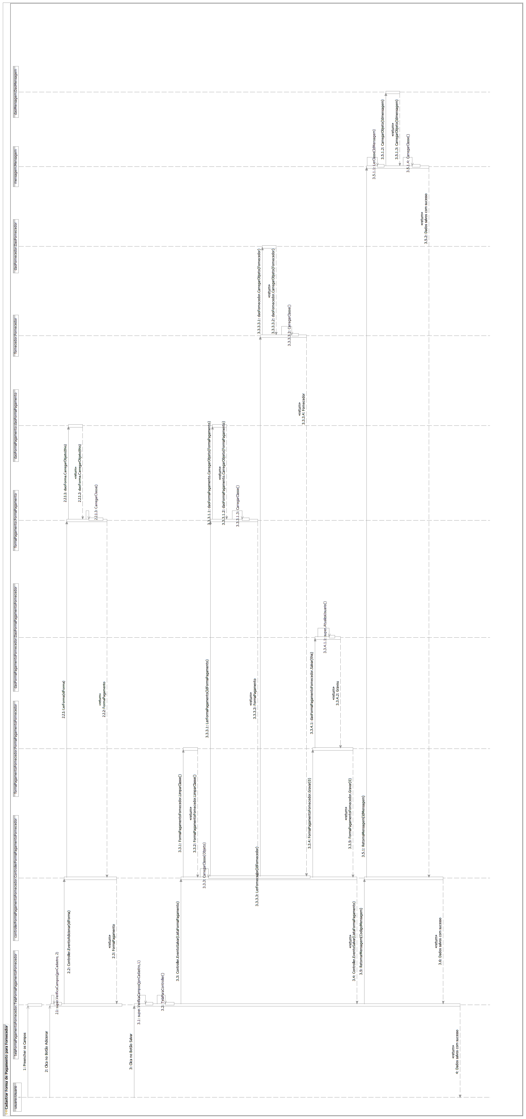

Fluxo Principal - Caso de Uso Cadastrar Fornecedor

[Each use case in the project has a unique identifier. Typically this reference is held in a database and used to cross-reference the use case against other requirements, such as those that might arise out of test plan.]
[The name is an active verb phrase, the goal of the primary actor, and something that the system can deliver to the primary actor.
e.g. Purchase Item, Withdraw Cash, Transfer Funds, Maintain Curve Definition…]
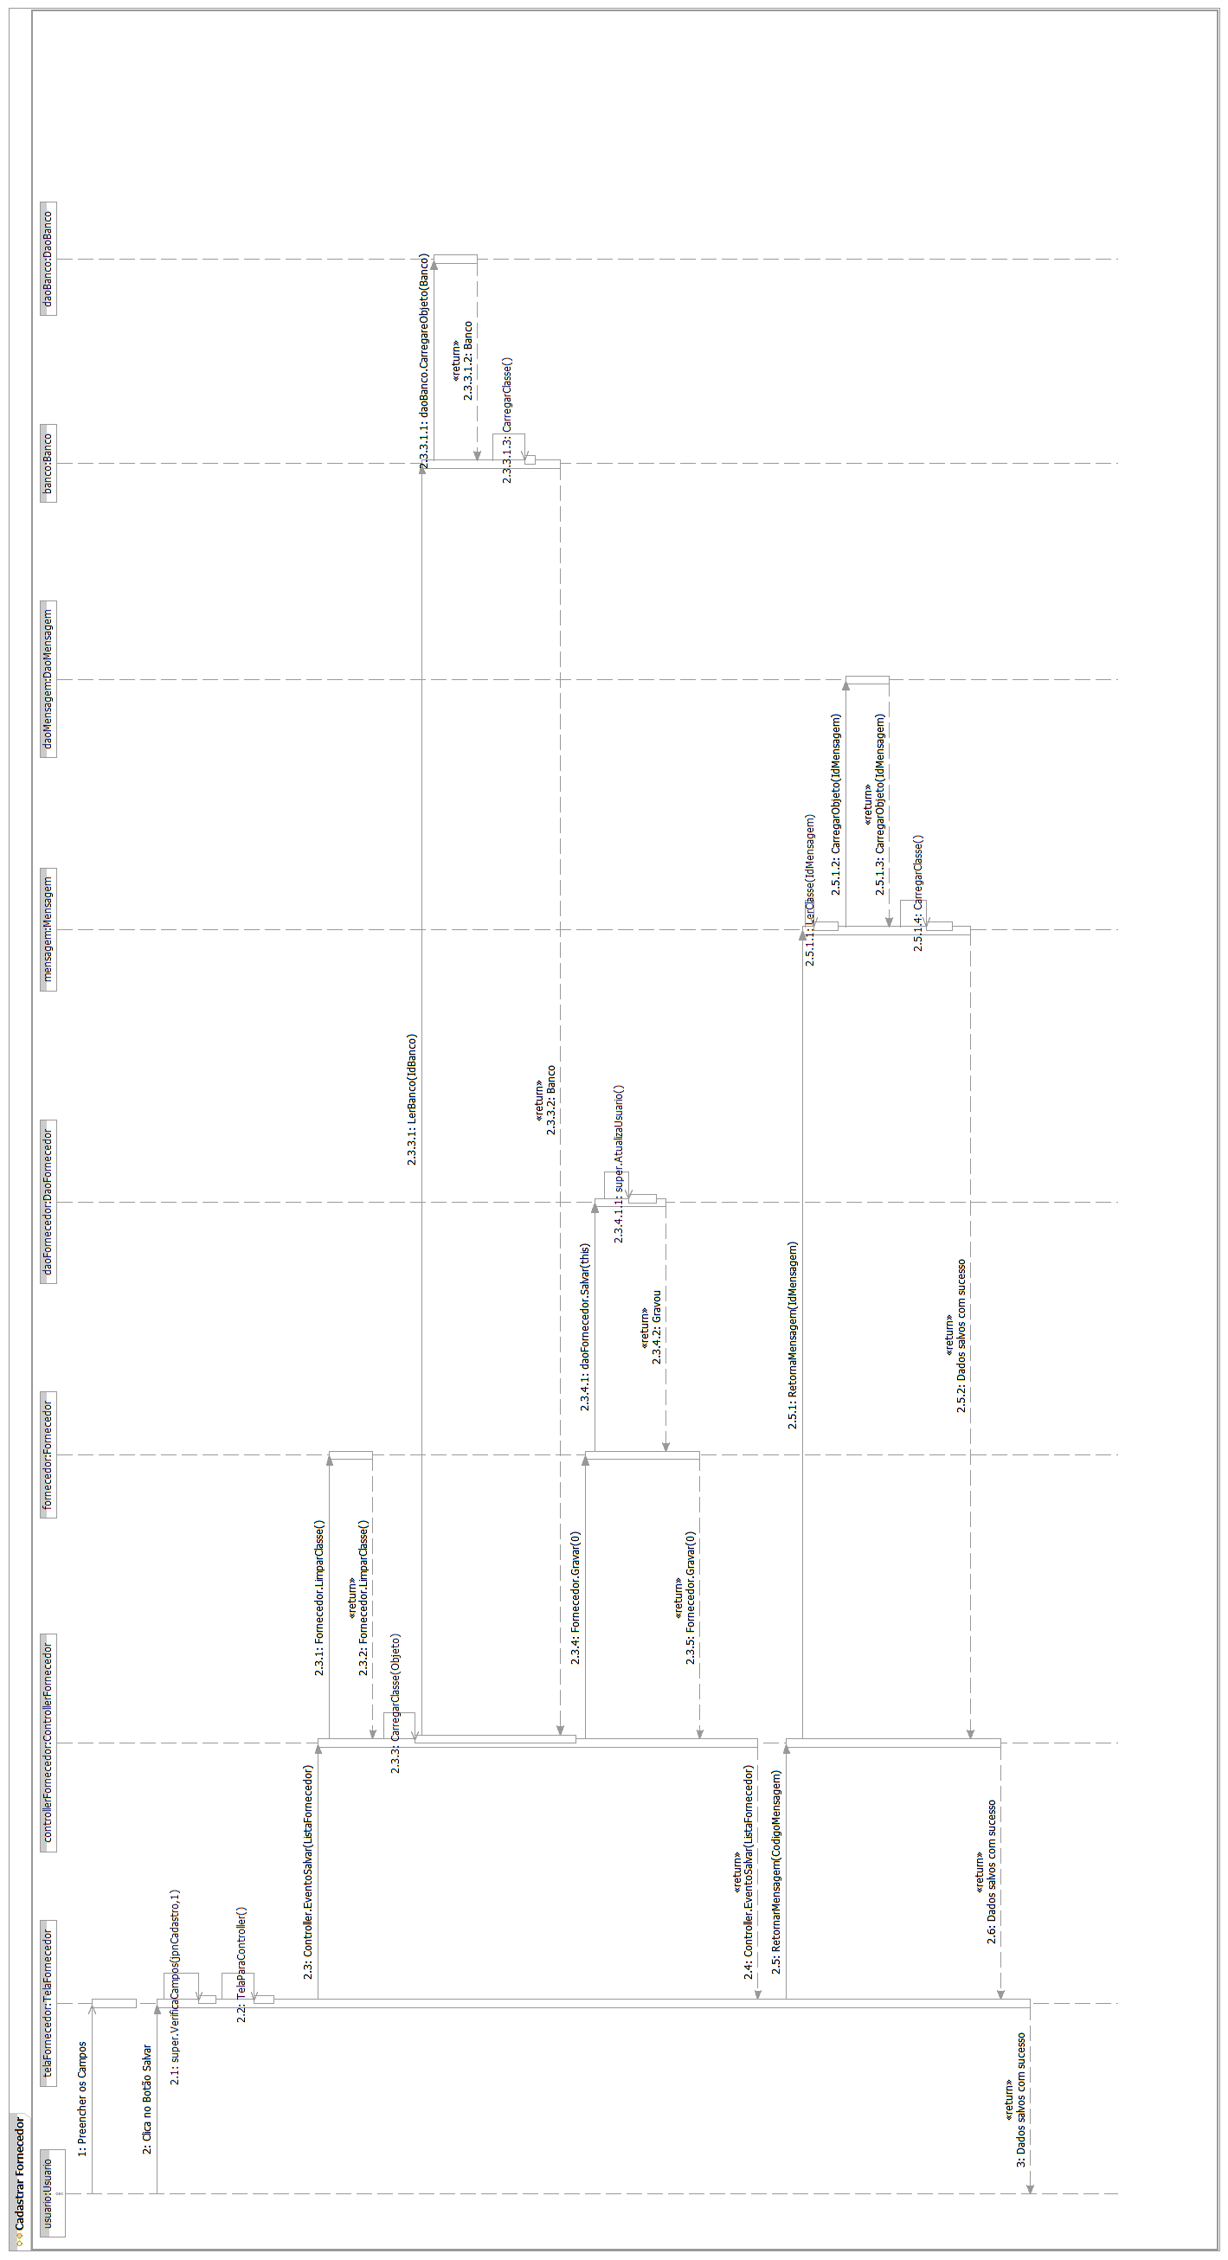
Fluxo Principal - Caso de Uso Cadastrar Fornecedor do Produto

[Each use case in the project has a unique identifier. Typically this reference is held in a database and used to cross-reference the use case against other requirements, such as those that might arise out of test plan.]
[The name is an active verb phrase, the goal of the primary actor, and something that the system can deliver to the primary actor.
e.g. Purchase Item, Withdraw Cash, Transfer Funds, Maintain Curve Definition…]
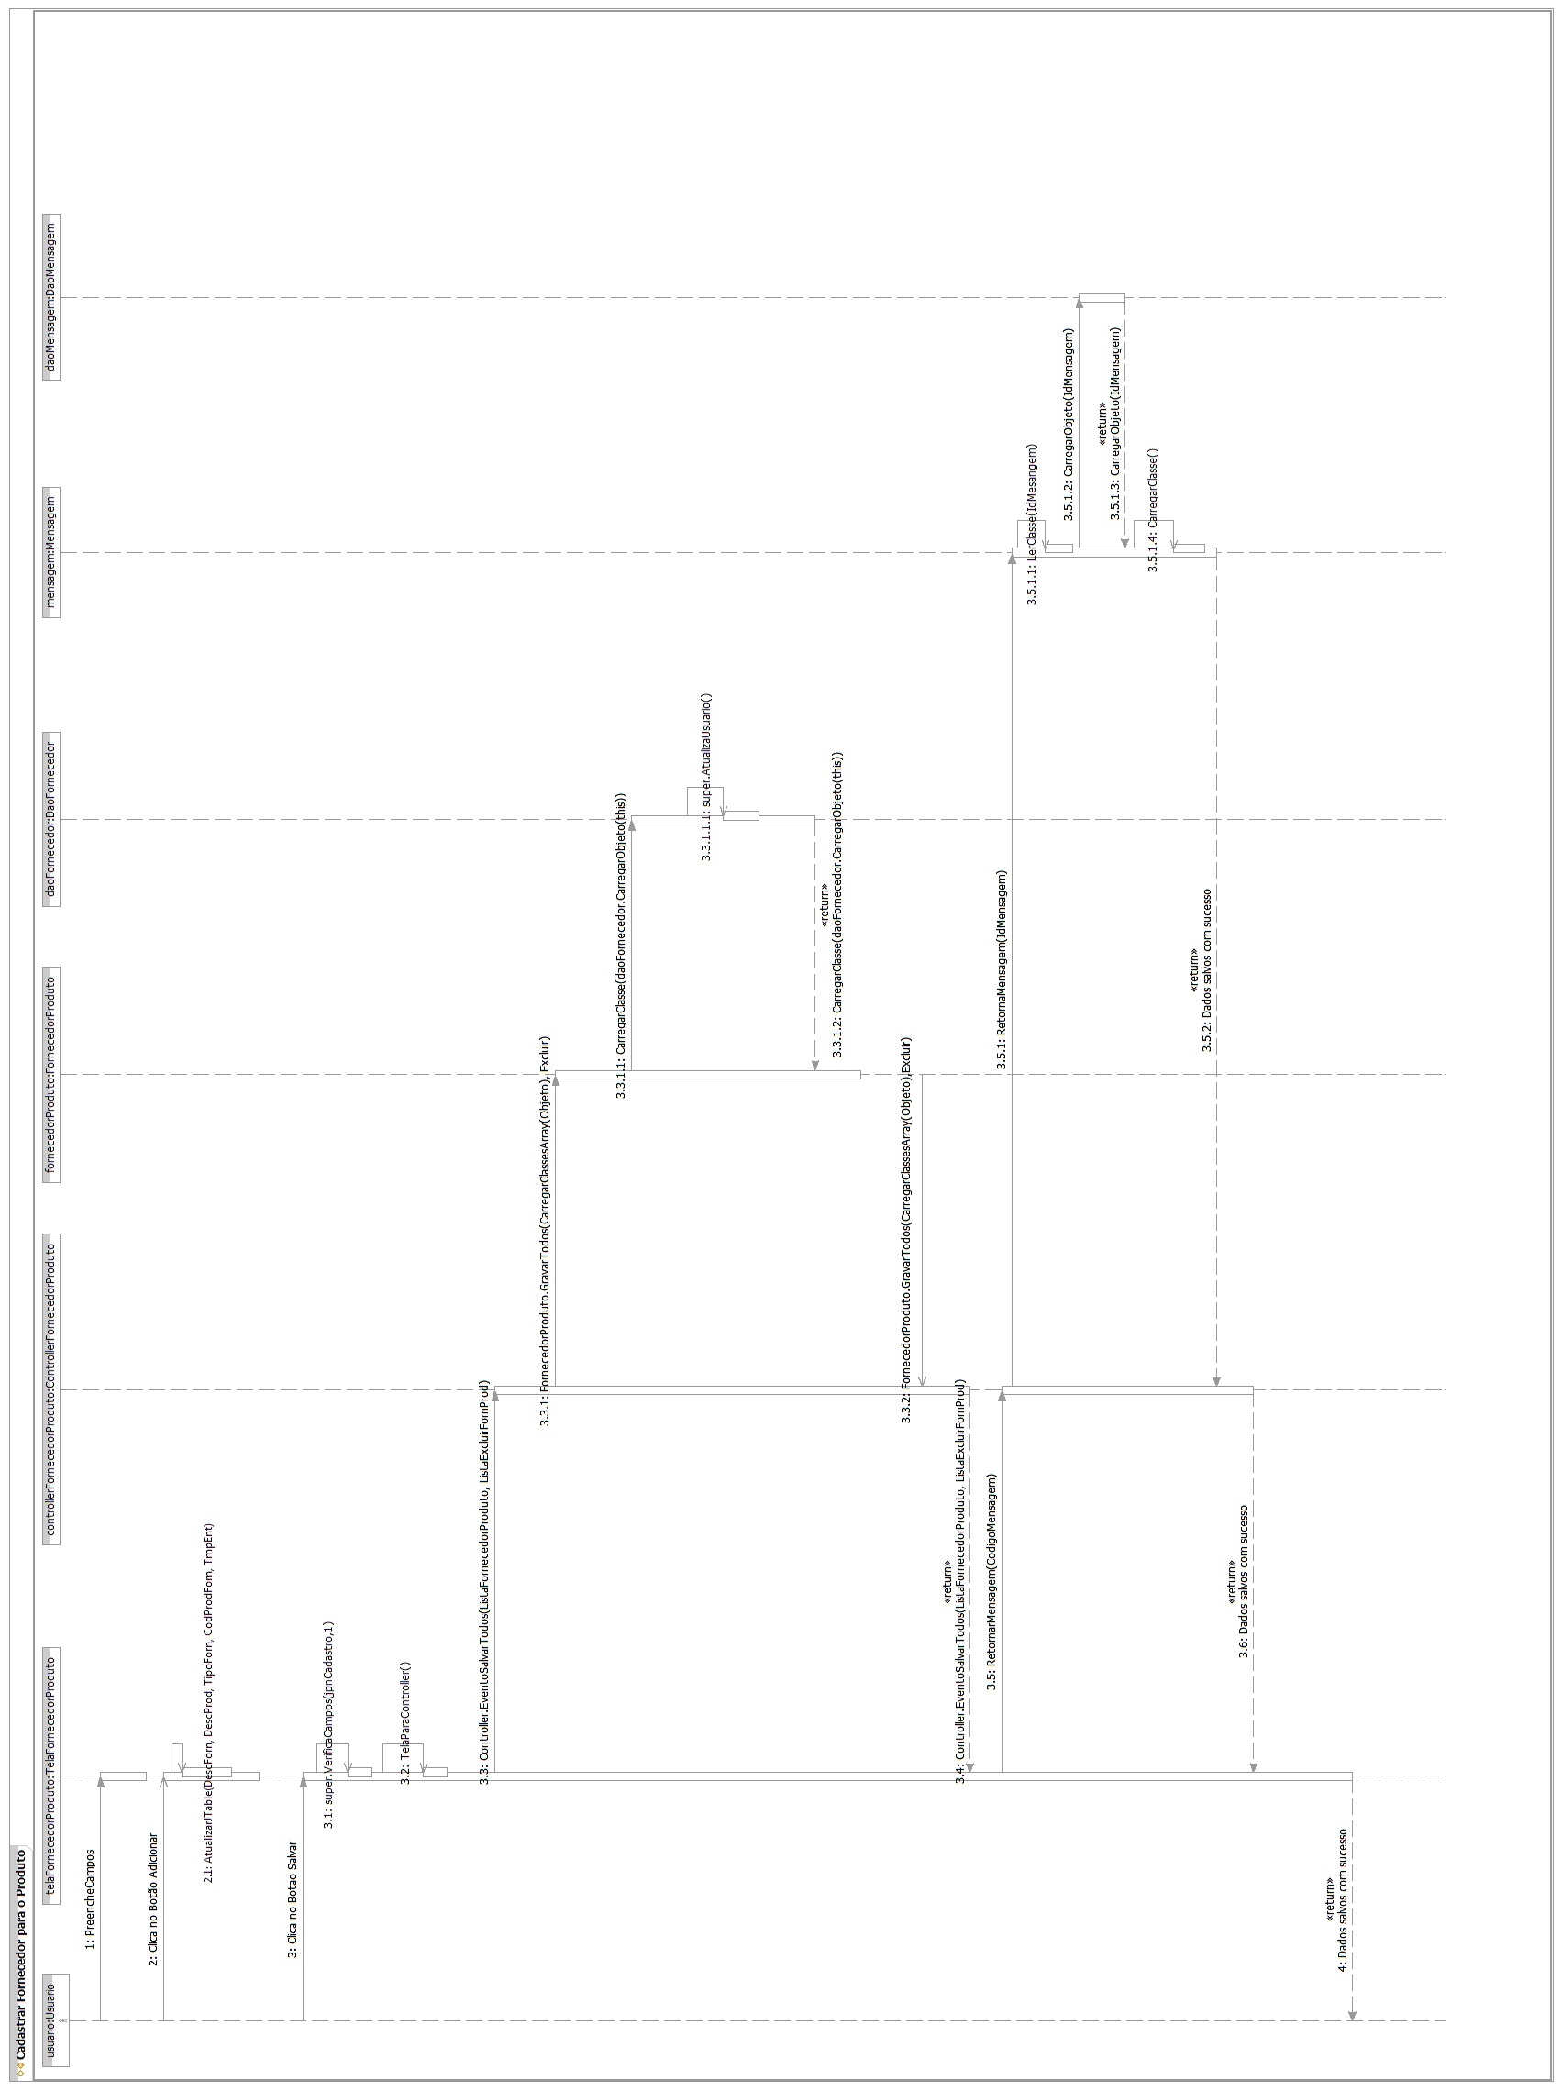
Fluxo Principal - Caso de Uso Cadastrar Motivo
[Each use case in the project has a unique identifier. Typically this reference is held in a database and used to cross-reference the use case against other requirements, such as those that might arise out of test plan.]
[The name is an active verb phrase, the goal of the primary actor, and something that the system can deliver to the primary actor.
e.g. Purchase Item, Withdraw Cash, Transfer Funds, Maintain Curve Definition…]

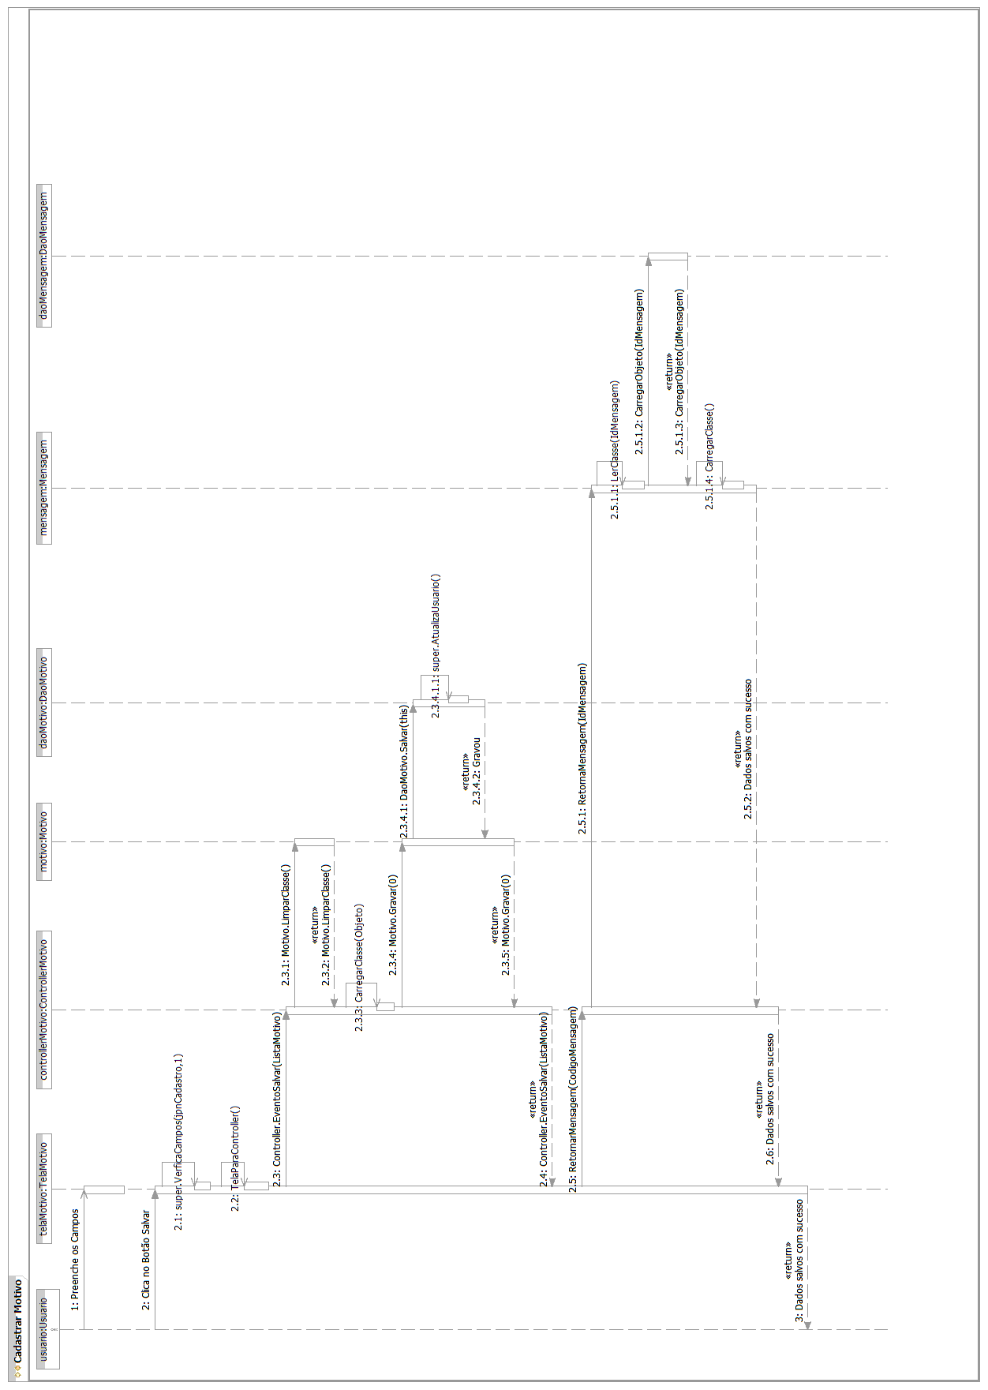
Fluxo Principal - Caso de Uso Cadastrar Ordem de Produção
[Each use case in the project has a unique identifier. Typically this reference is held in a database and used to cross-reference the use case against other requirements, such as those that might arise out of test plan.]
[The name is an active verb phrase, the goal of the primary actor, and something that the system can deliver to the primary actor.
e.g. Purchase Item, Withdraw Cash, Transfer Funds, Maintain Curve Definition…]

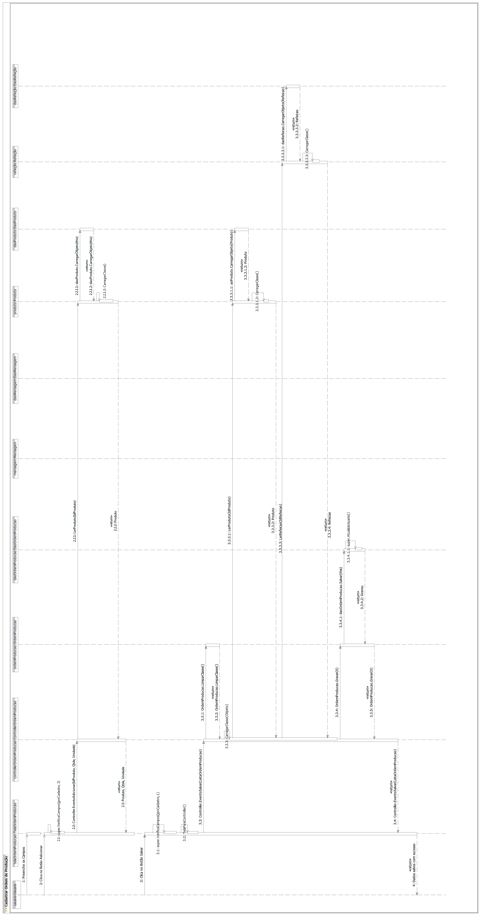
Fluxo Principal - Caso de Uso Cadastrar Pedido

[Each use case in the project has a unique identifier. Typically this reference is held in a database and used to cross-reference the use case against other requirements, such as those that might arise out of test plan.]
[The name is an active verb phrase, the goal of the primary actor, and something that the system can deliver to the primary actor.
e.g. Purchase Item, Withdraw Cash, Transfer Funds, Maintain Curve Definition…]
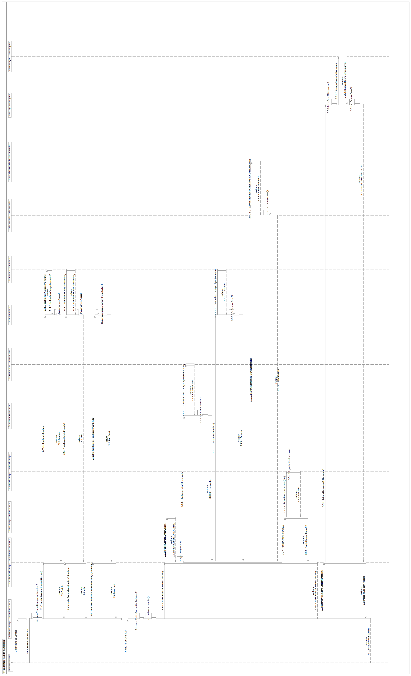

Fluxo Principal – Caso de Uso Cadastrar Perfil
[Each use case in the project has a unique identifier. Typically this reference is held in a database and used to cross-reference the use case against other requirements, such as those that might arise out of test plan.]
[The name is an active verb phrase, the goal of the primary actor, and something that the system can deliver to the primary actor.
e.g. Purchase Item, Withdraw Cash, Transfer Funds, Maintain Curve Definition…]

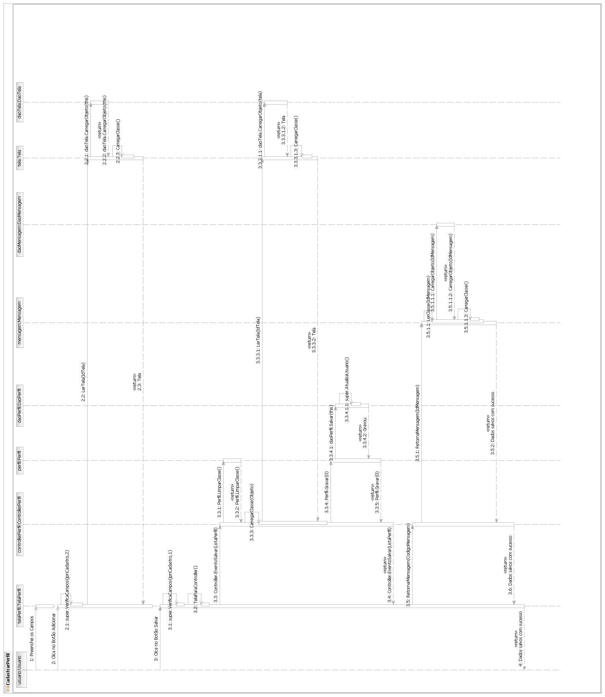
Fluxo Principal - Caso de Uso Cadastrar Produto
[Each use case in the project has a unique identifier. Typically this reference is held in a database and used to cross-reference the use case against other requirements, such as those that might arise out of test plan.]
[The name is an active verb phrase, the goal of the primary actor, and something that the system can deliver to the primary actor.
e.g. Purchase Item, Withdraw Cash, Transfer Funds, Maintain Curve Definition…]
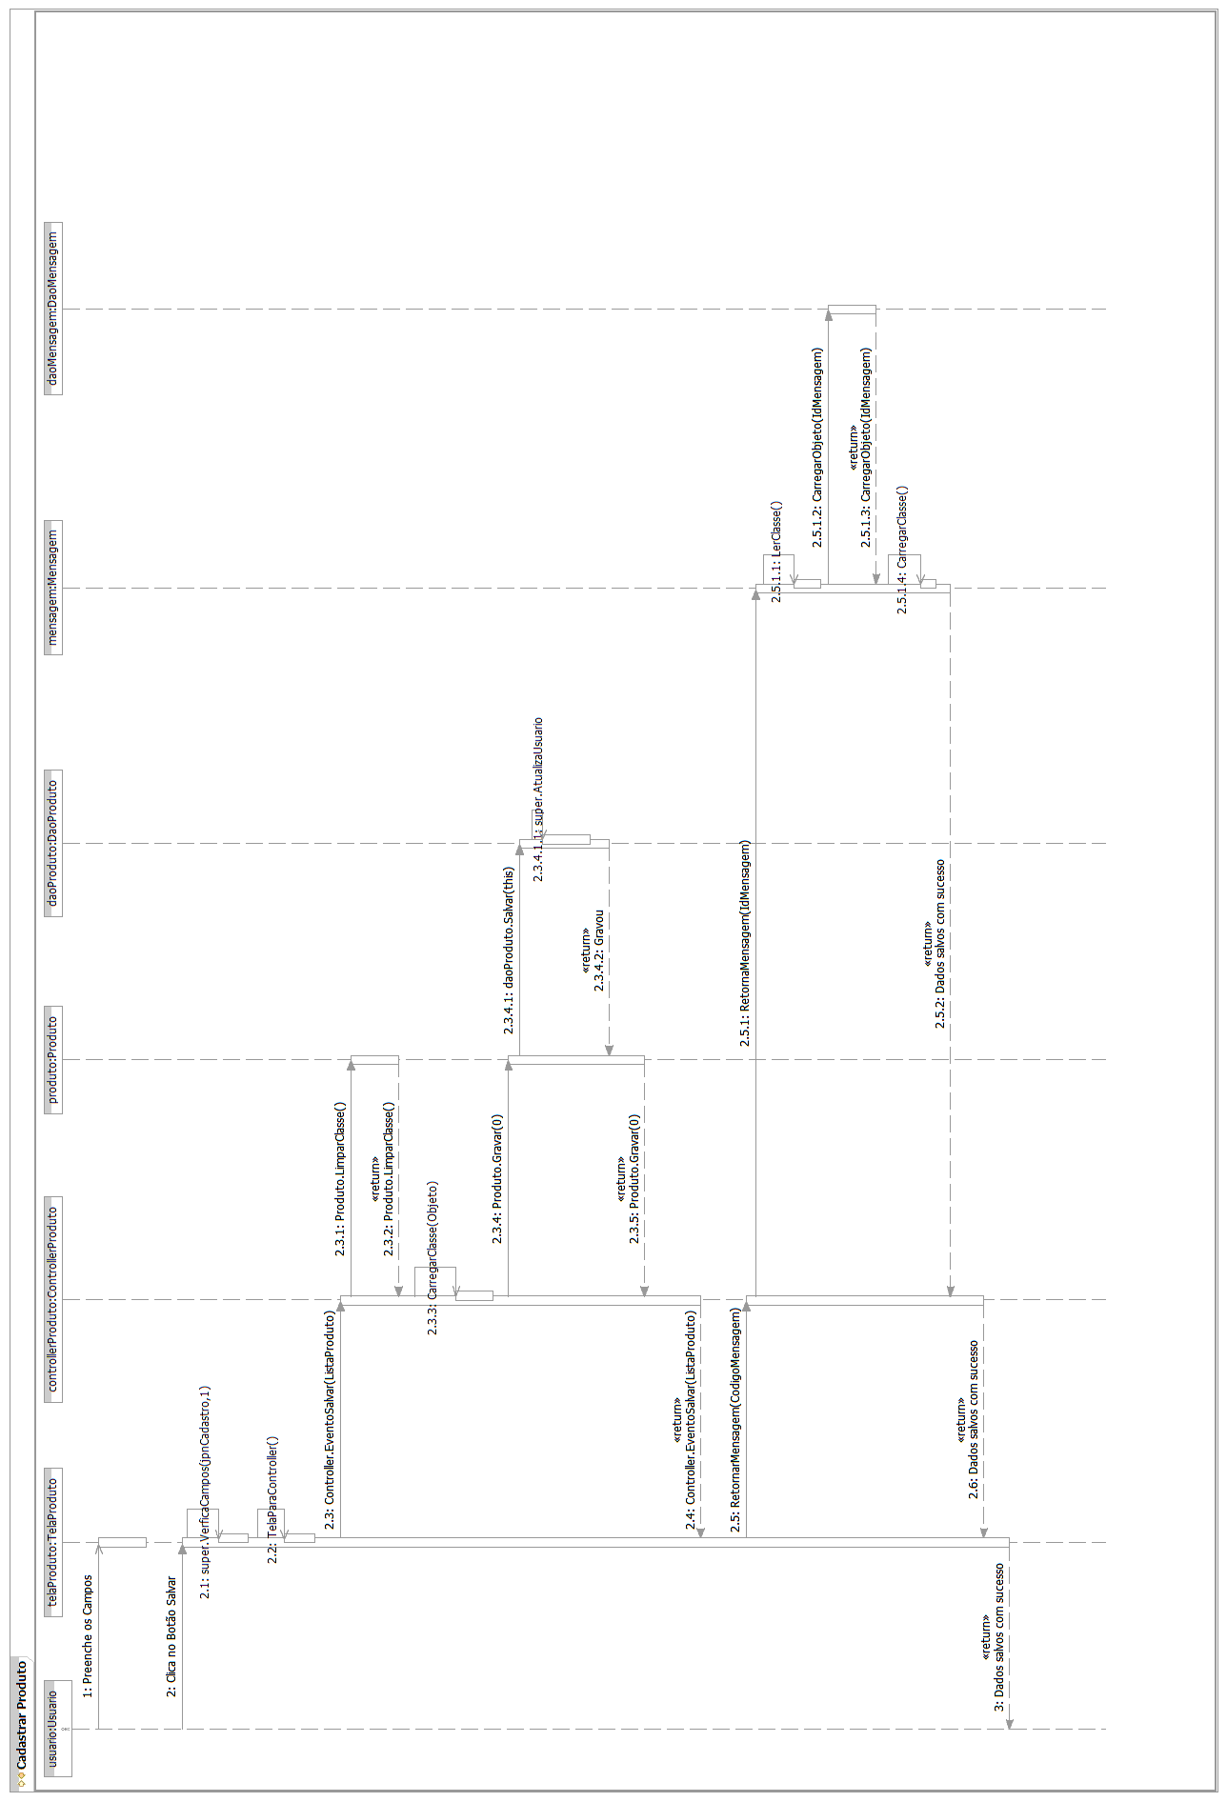

Fluxo Principal - Caso de Uso Cadastrar Refeição
[Each use case in the project has a unique identifier. Typically this reference is held in a database and used to cross-reference the use case against other requirements, such as those that might arise out of test plan.]
[The name is an active verb phrase, the goal of the primary actor, and something that the system can deliver to the primary actor.
e.g. Purchase Item, Withdraw Cash, Transfer Funds, Maintain Curve Definition…]

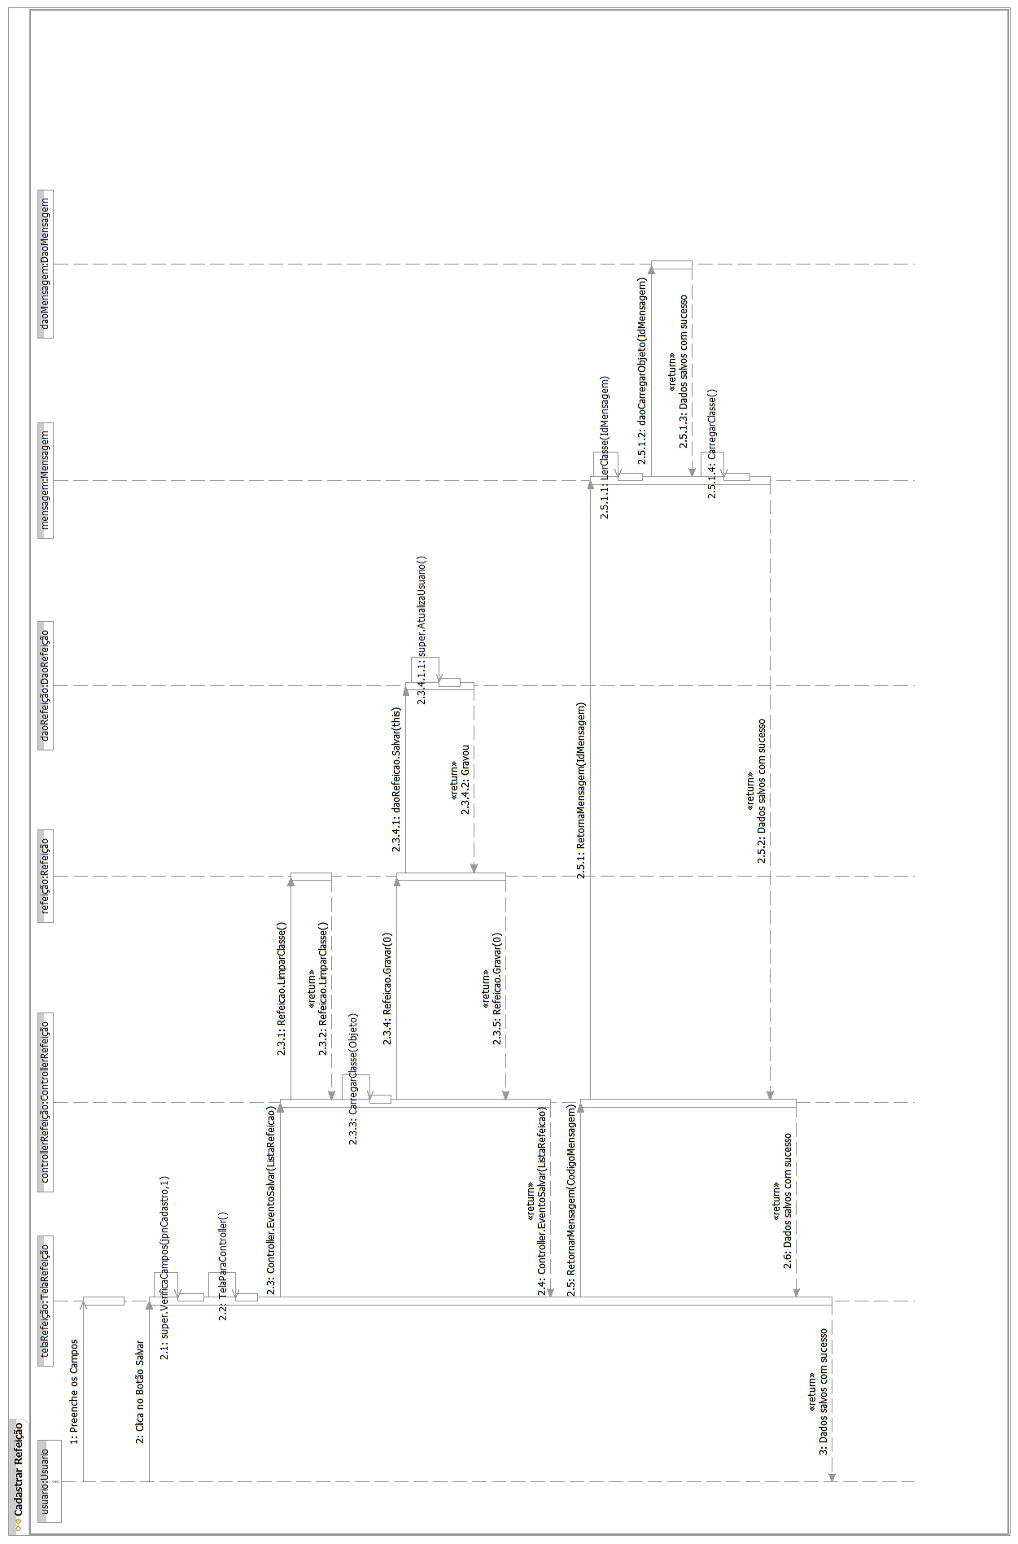

Fluxo Principal – Caso de Uso Cadastrar Tela
[Each use case in the project has a unique identifier. Typically this reference is held in a database and used to cross-reference the use case against other requirements, such as those that might arise out of test plan.]
[The name is an active verb phrase, the goal of the primary actor, and something that the system can deliver to the primary actor.
e.g. Purchase Item, Withdraw Cash, Transfer Funds, Maintain Curve Definition…]

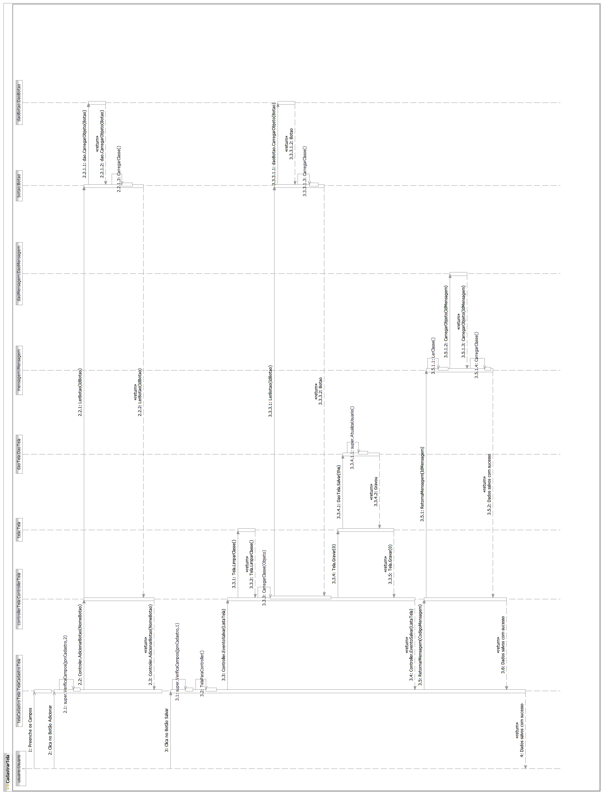

Fluxo Principal – Caso de Uso Cadastrar Unidade de Medida
[Each use case in the project has a unique identifier. Typically this reference is held in a database and used to cross-reference the use case against other requirements, such as those that might arise out of test plan.]
[The name is an active verb phrase, the goal of the primary actor, and something that the system can deliver to the primary actor.
e.g. Purchase Item, Withdraw Cash, Transfer Funds, Maintain Curve Definition…]

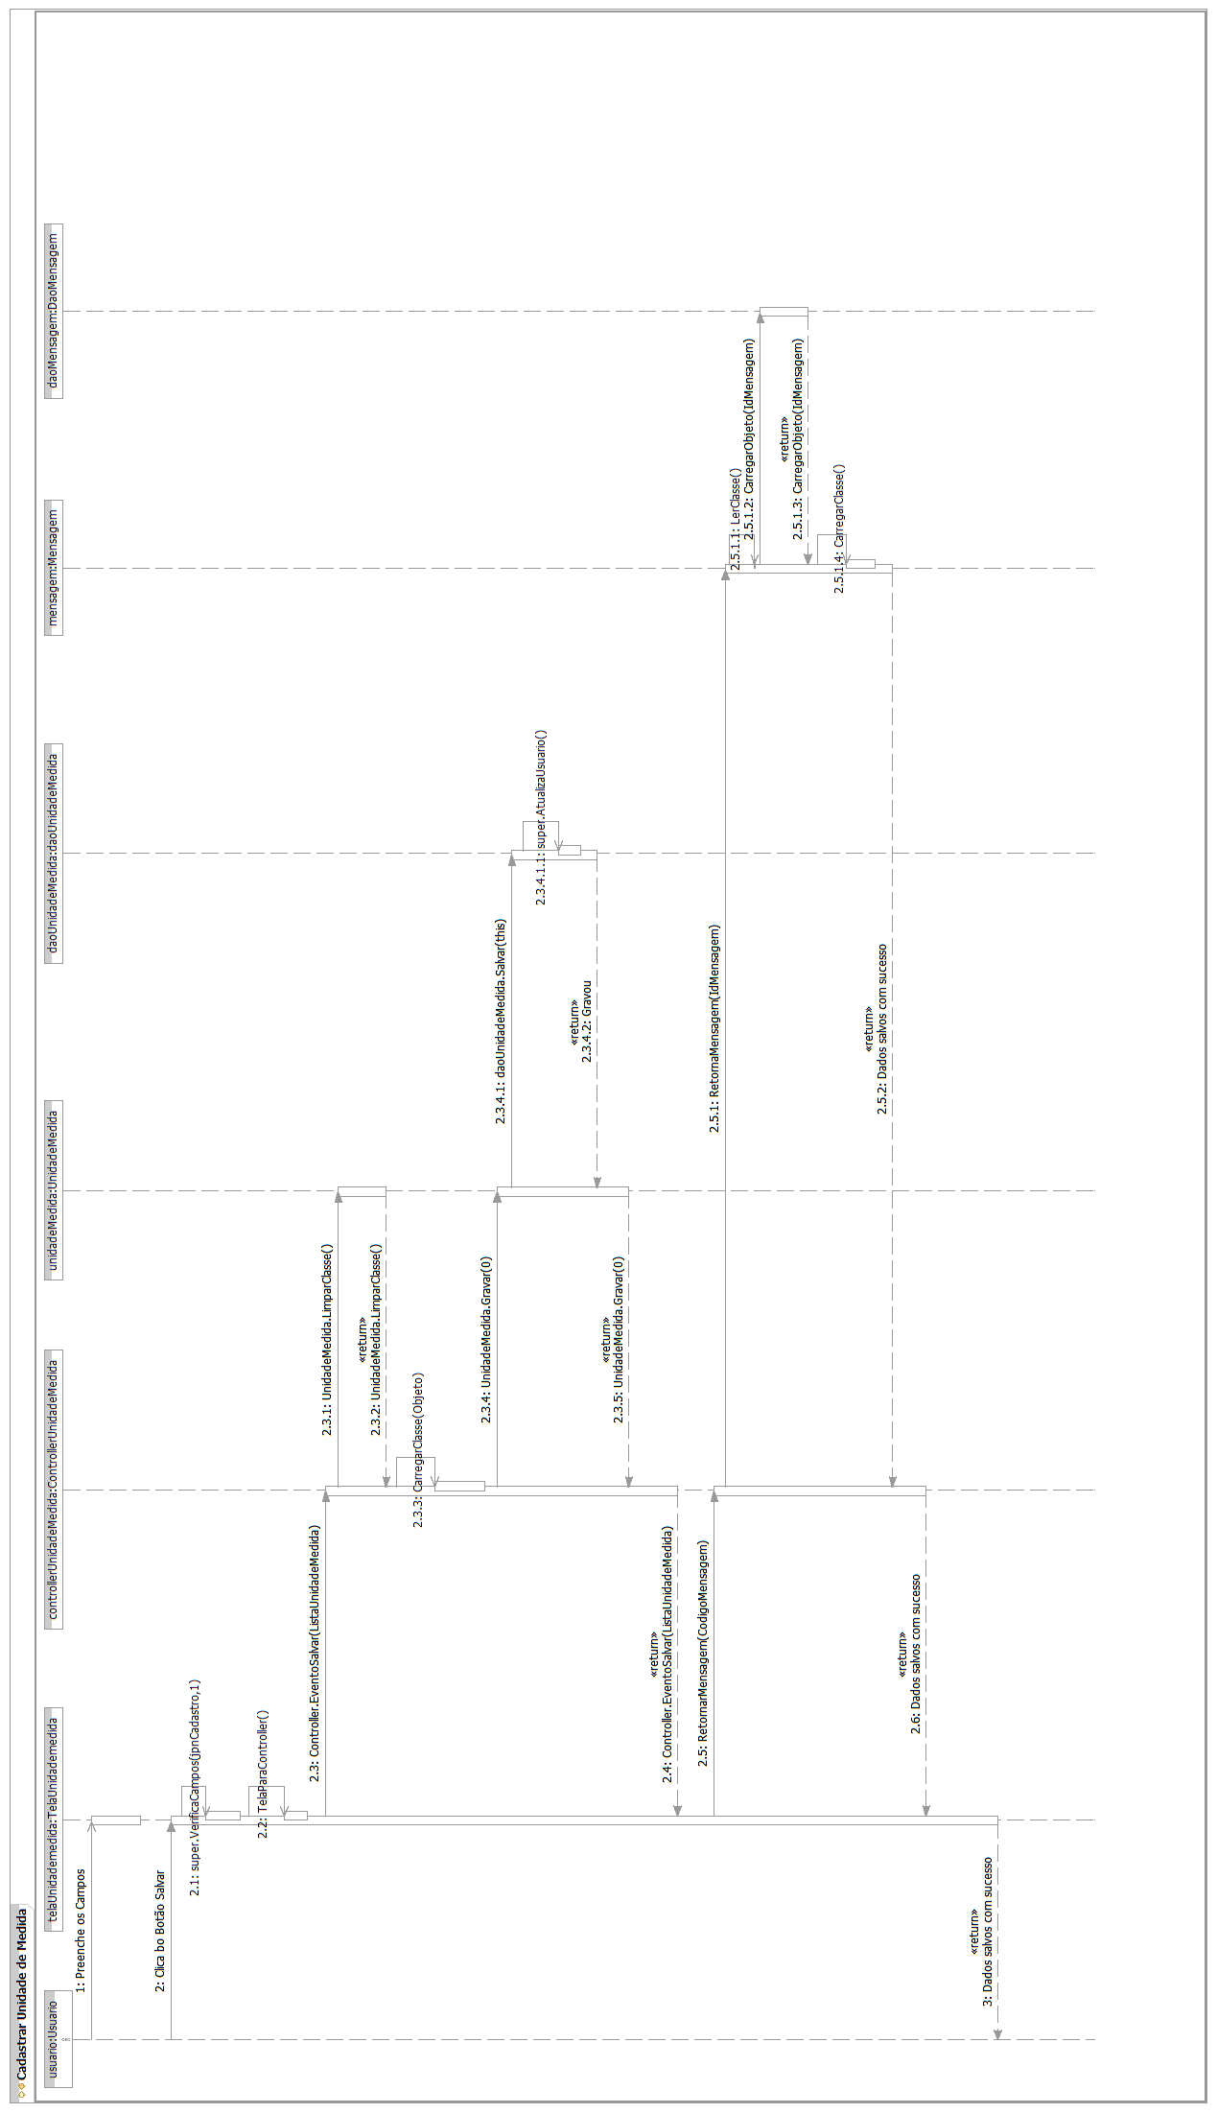

Fluxo Principal – Caso de Uso Cadastrar Usuário
[Each use case in the project has a unique identifier. Typically this reference is held in a database and used to cross-reference the use case against other requirements, such as those that might arise out of test plan.]
[The name is an active verb phrase, the goal of the primary actor, and something that the system can deliver to the primary actor.
e.g. Purchase Item, Withdraw Cash, Transfer Funds, Maintain Curve Definition…]

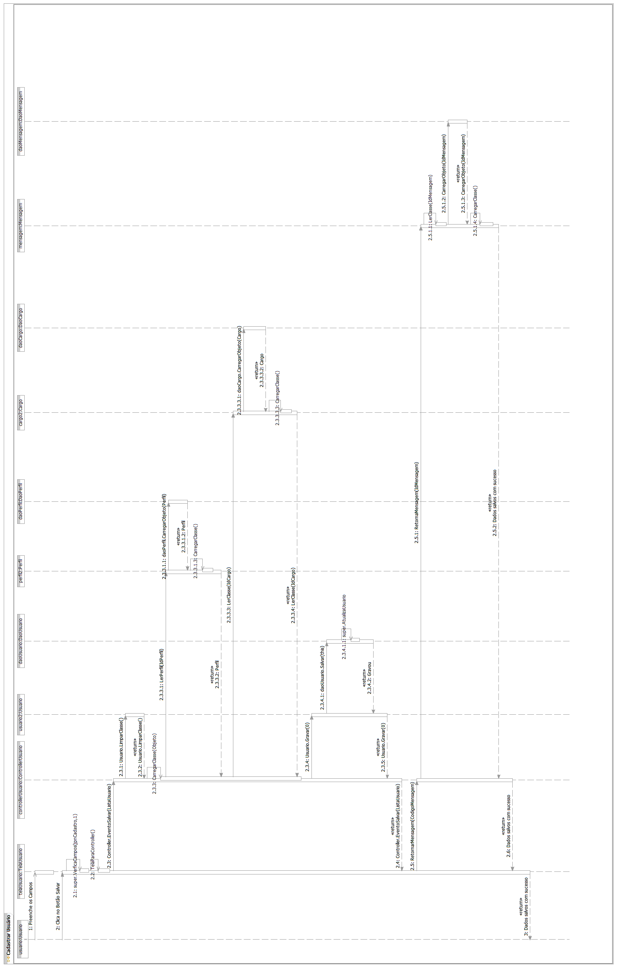

Fluxo Principal – Caso de Uso Pesquisar Banco
[Each use case in the project has a unique identifier. Typically this reference is held in a database and used to cross-reference the use case against other requirements, such as those that might arise out of test plan.]
[The name is an active verb phrase, the goal of the primary actor, and something that the system can deliver to the primary actor.
e.g. Purchase Item, Withdraw Cash, Transfer Funds, Maintain Curve Definition…]

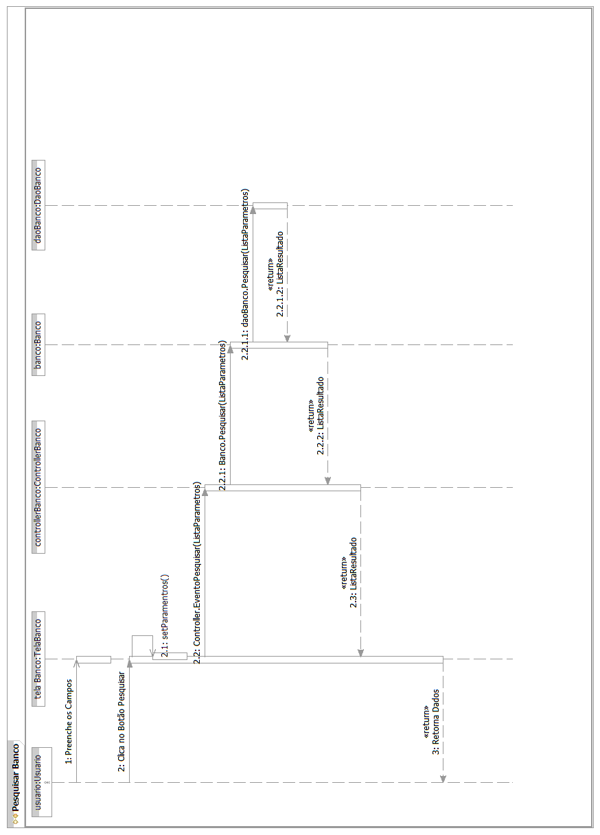

Fluxo Principal – Caso de Uso Pesquisar Botão
[Each use case in the project has a unique identifier. Typically this reference is held in a database and used to cross-reference the use case against other requirements, such as those that might arise out of test plan.]
[The name is an active verb phrase, the goal of the primary actor, and something that the system can deliver to the primary actor.
e.g. Purchase Item, Withdraw Cash, Transfer Funds, Maintain Curve Definition…]
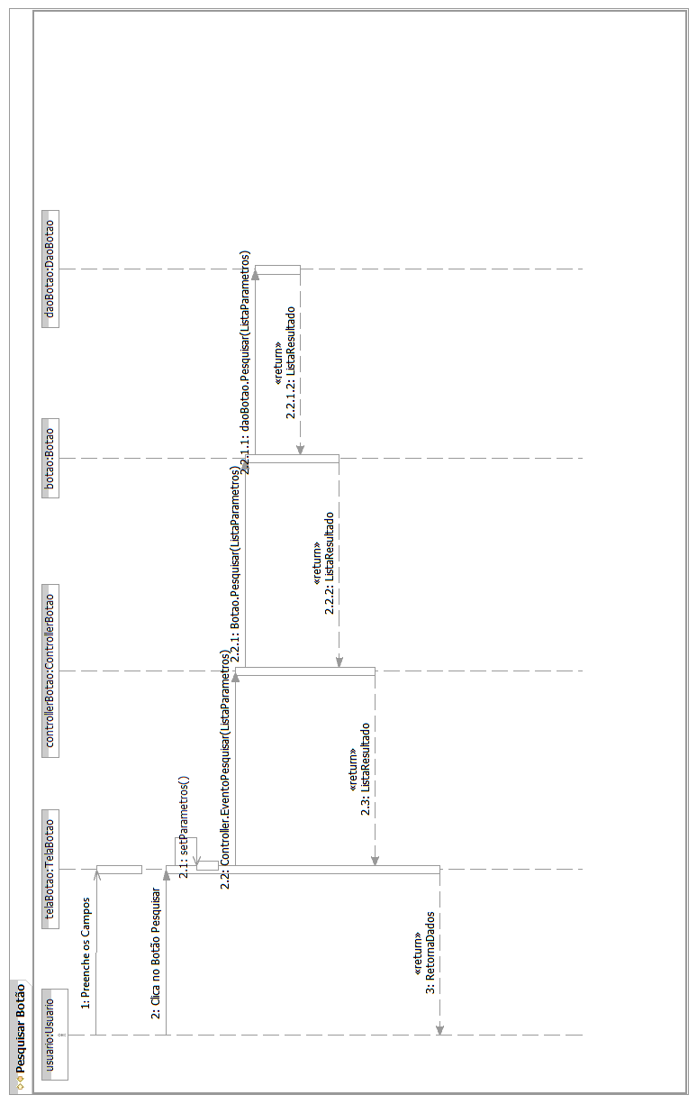
Fluxo Principal – Caso de Uso Pesquisar Cardápio

[Each use case in the project has a unique identifier. Typically this reference is held in a database and used to cross-reference the use case against other requirements, such as those that might arise out of test plan.]
[The name is an active verb phrase, the goal of the primary actor, and something that the system can deliver to the primary actor.
e.g. Purchase Item, Withdraw Cash, Transfer Funds, Maintain Curve Definition…]
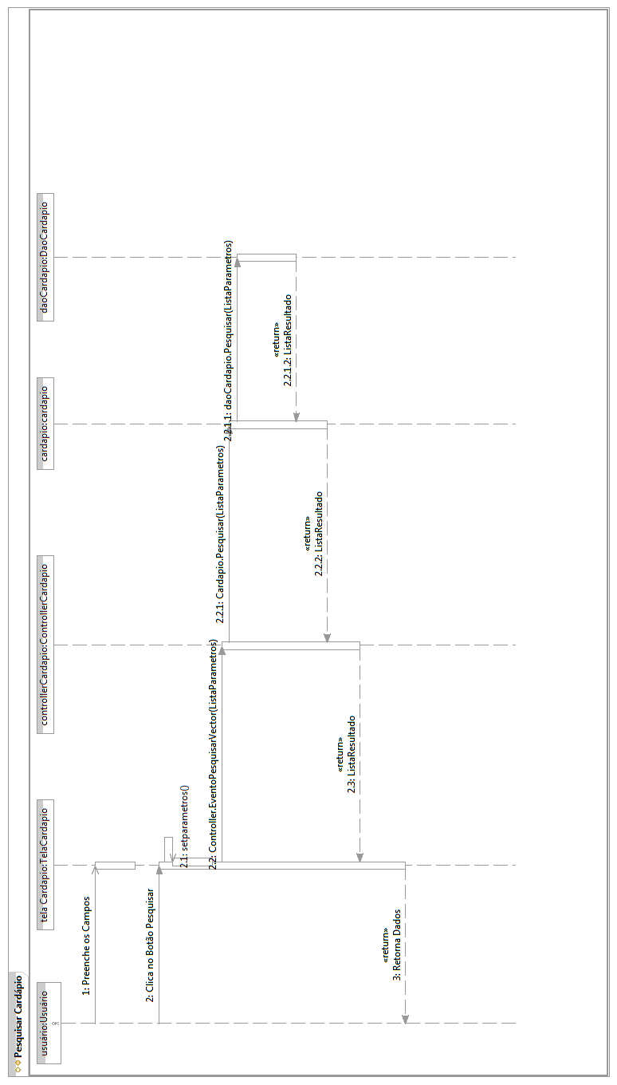
Fluxo Principal – Caso de Uso Pesquisar Cargo

[Each use case in the project has a unique identifier. Typically this reference is held in a database and used to cross-reference the use case against other requirements, such as those that might arise out of test plan.]
[The name is an active verb phrase, the goal of the primary actor, and something that the system can deliver to the primary actor.
e.g. Purchase Item, Withdraw Cash, Transfer Funds, Maintain Curve Definition…]
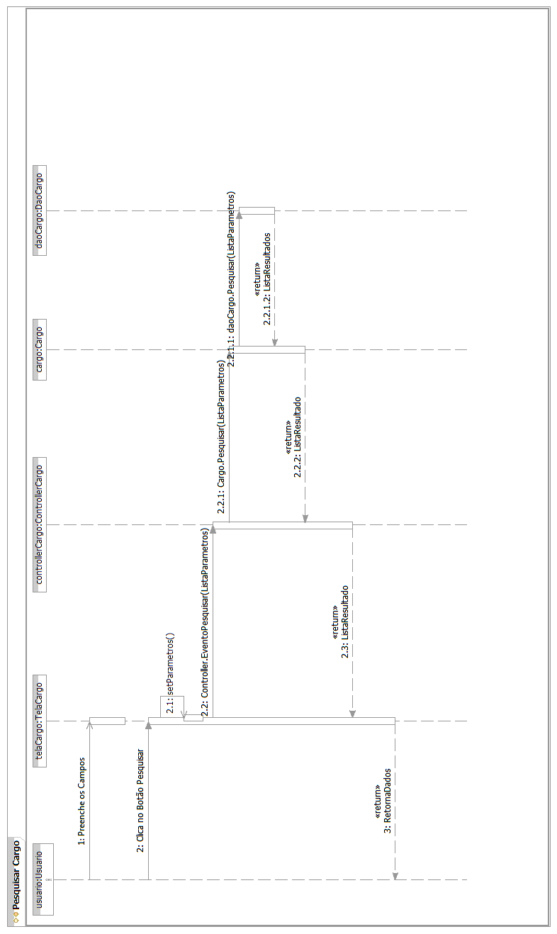
Fluxo Principal – Caso de Uso Pesquisar Composição Centesimal

[Each use case in the project has a unique identifier. Typically this reference is held in a database and used to cross-reference the use case against other requirements, such as those that might arise out of test plan.]
[The name is an active verb phrase, the goal of the primary actor, and something that the system can deliver to the primary actor.
e.g. Purchase Item, Withdraw Cash, Transfer Funds, Maintain Curve Definition…]
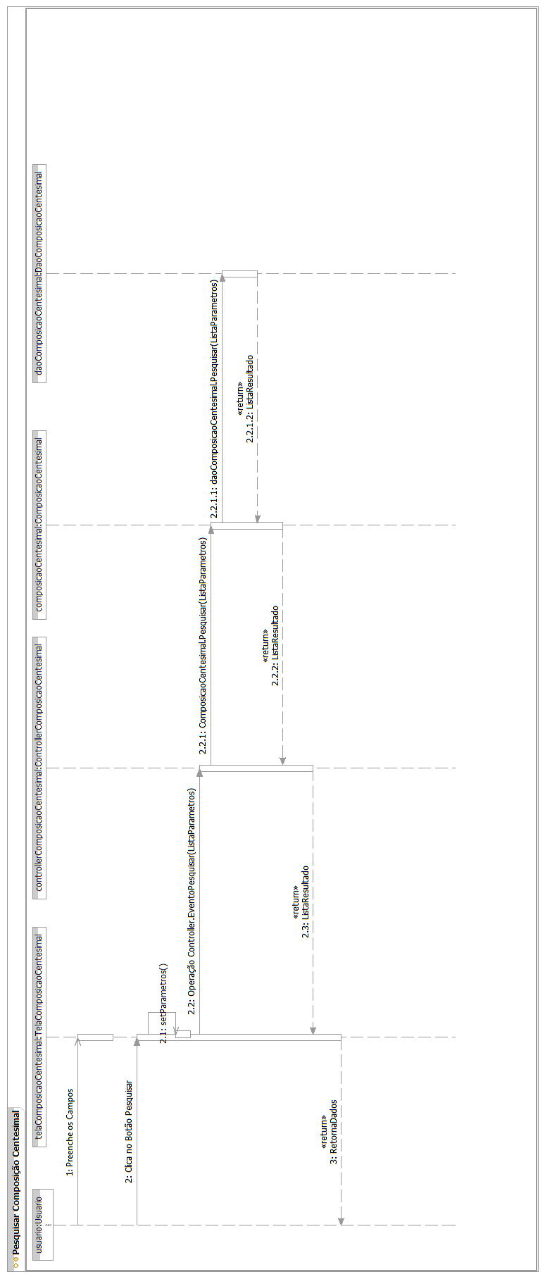
Fluxo Principal – Caso de Uso Pesquisar Contato do Fornecedor
[Each use case in the project has a unique identifier. Typically this reference is held in a database and used to cross-reference the use case against other requirements, such as those that might arise out of test plan.]
[The name is an active verb phrase, the goal of the primary actor, and something that the system can deliver to the primary actor.
e.g. Purchase Item, Withdraw Cash, Transfer Funds, Maintain Curve Definition…]

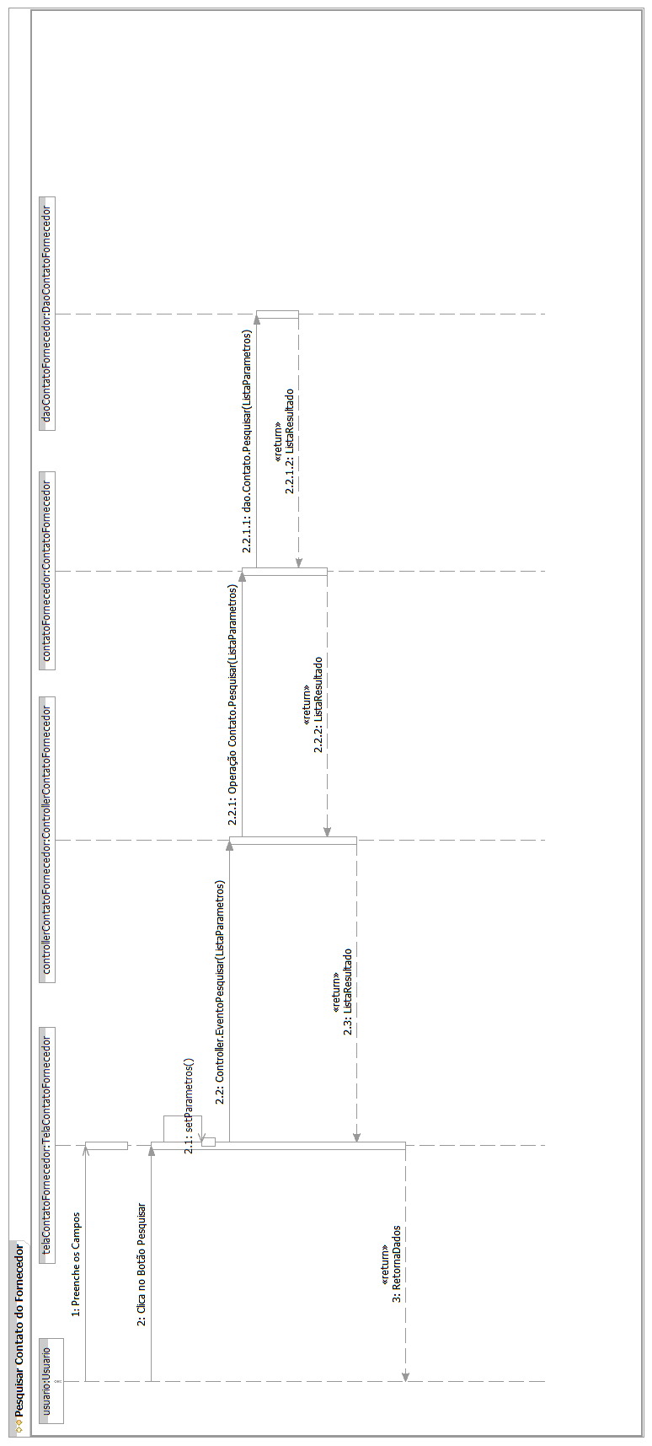
Fluxo Principal – Caso de Uso Pesquisar Movimentação do Estoque
[Each use case in the project has a unique identifier. Typically this reference is held in a database and used to cross-reference the use case against other requirements, such as those that might arise out of test plan.]
[The name is an active verb phrase, the goal of the primary actor, and something that the system can deliver to the primary actor.
e.g. Purchase Item, Withdraw Cash, Transfer Funds, Maintain Curve Definition…]

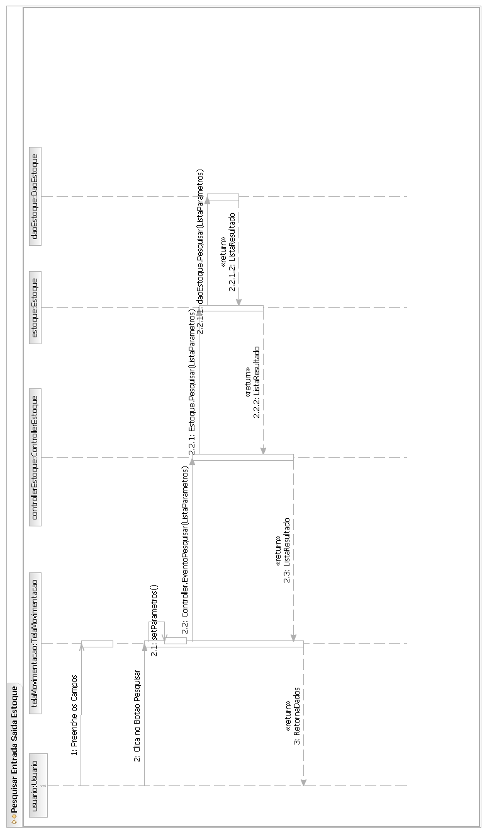

Fluxo Principal – Caso de Uso Pesquisar Ficha Técnica
[Each use case in the project has a unique identifier. Typically this reference is held in a database and used to cross-reference the use case against other requirements, such as those that might arise out of test plan.]
[The name is an active verb phrase, the goal of the primary actor, and something that the system can deliver to the primary actor.
e.g. Purchase Item, Withdraw Cash, Transfer Funds, Maintain Curve Definition…]

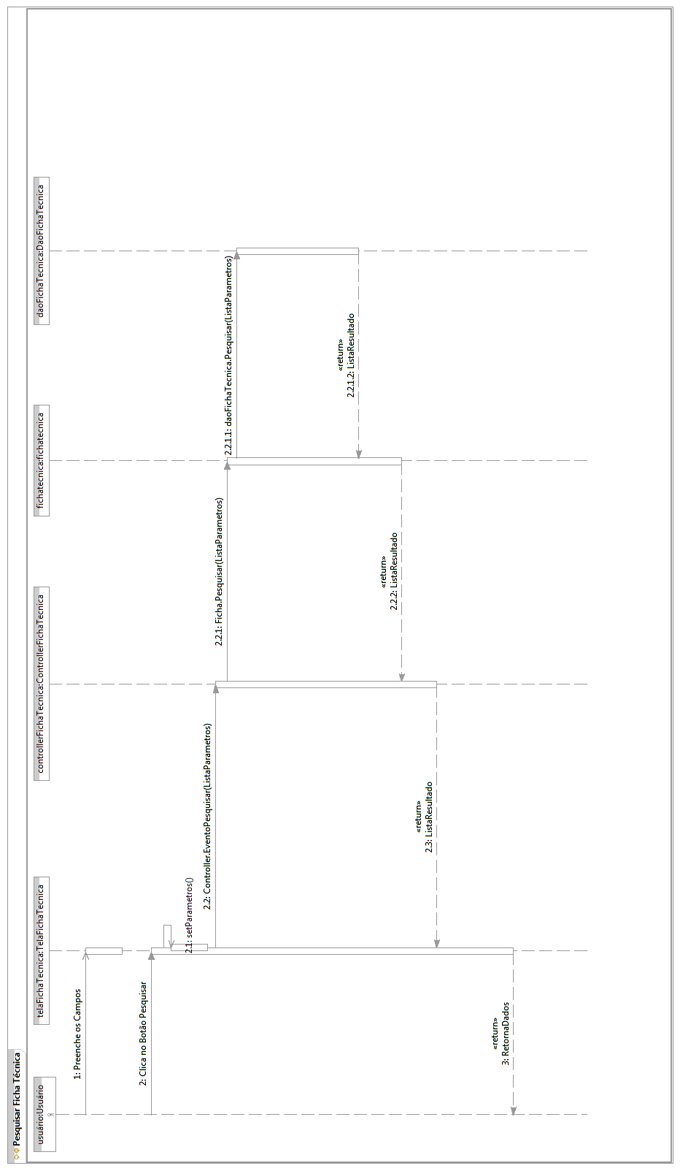

Fluxo Principal – Caso de Uso Pesquisar Forma de Pagamento

[Each use case in the project has a unique identifier. Typically this reference is held in a database and used to cross-reference the use case against other requirements, such as those that might arise out of test plan.]
[The name is an active verb phrase, the goal of the primary actor, and something that the system can deliver to the primary actor.
e.g. Purchase Item, Withdraw Cash, Transfer Funds, Maintain Curve Definition…]
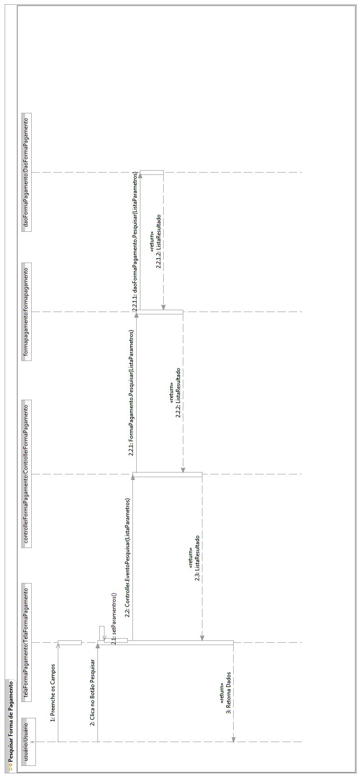
Fluxo Principal – Caso de Uso Pesquisar Forma de Pagamento do Fornecedor

[Each use case in the project has a unique identifier. Typically this reference is held in a database and used to cross-reference the use case against other requirements, such as those that might arise out of test plan.]
[The name is an active verb phrase, the goal of the primary actor, and something that the system can deliver to the primary actor.
e.g. Purchase Item, Withdraw Cash, Transfer Funds, Maintain Curve Definition…]
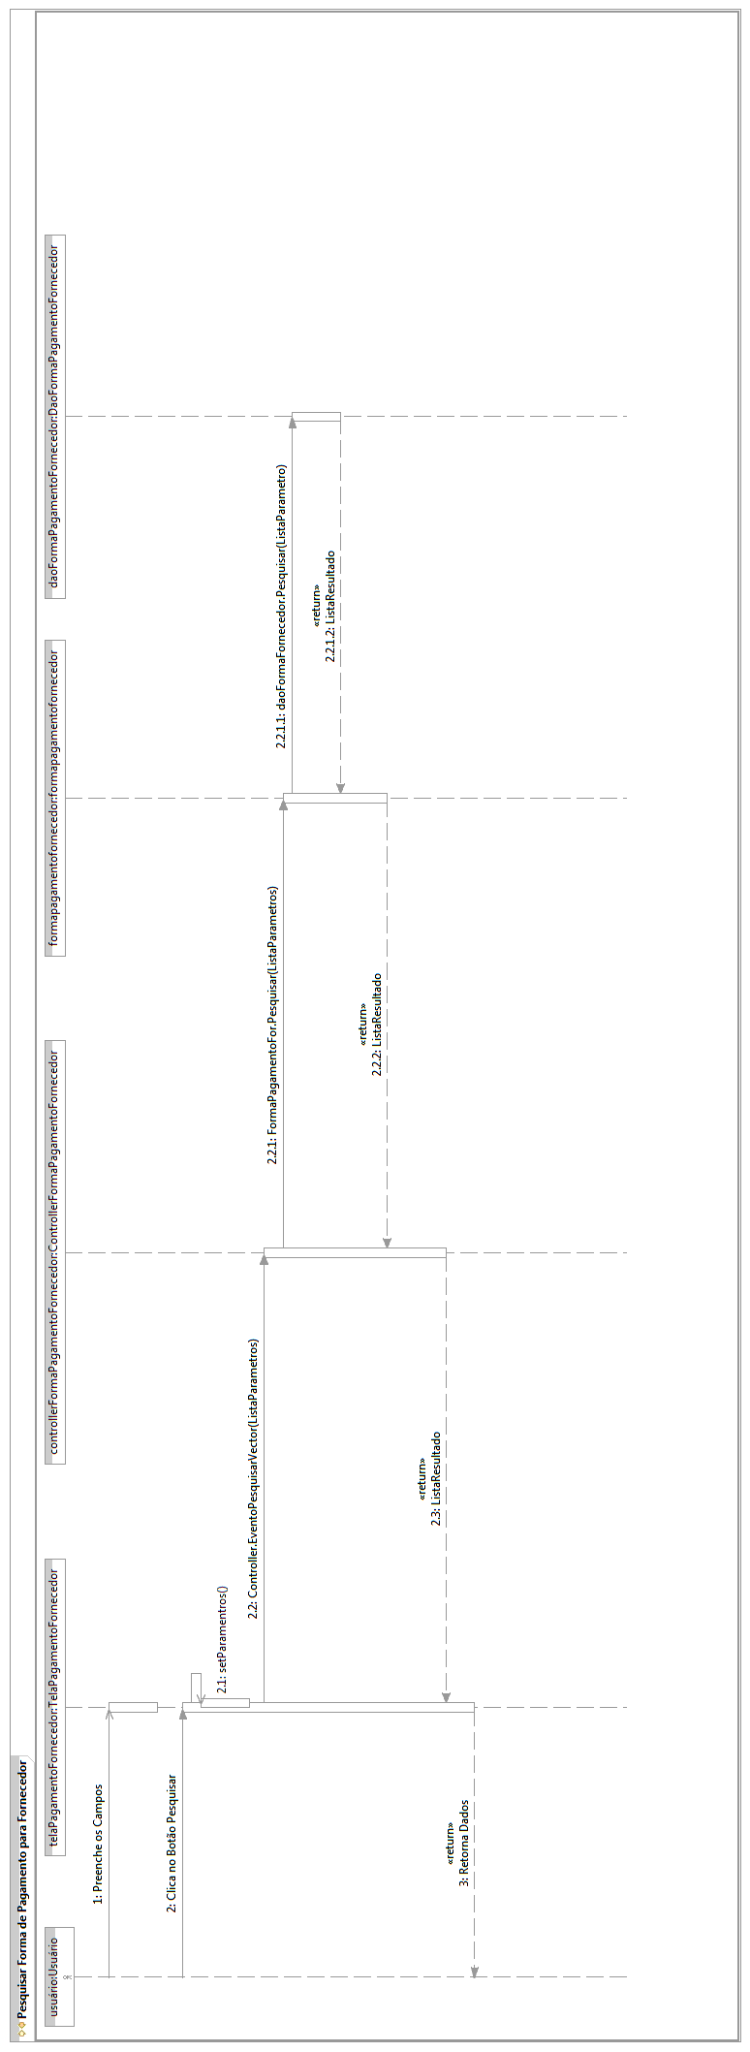
Fluxo Principal – Caso de Uso Pesquisar Fornecedor

[Each use case in the project has a unique identifier. Typically this reference is held in a database and used to cross-reference the use case against other requirements, such as those that might arise out of test plan.]
[The name is an active verb phrase, the goal of the primary actor, and something that the system can deliver to the primary actor.
e.g. Purchase Item, Withdraw Cash, Transfer Funds, Maintain Curve Definition…]
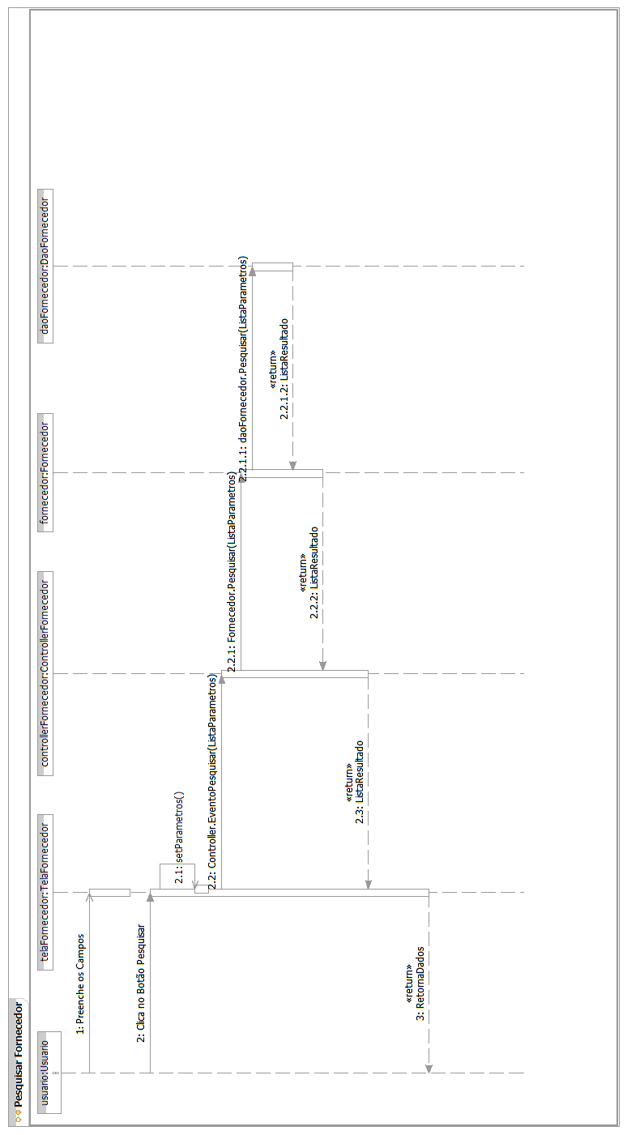

Fluxo Principal – Caso de Uso Pesquisar Fornecedor do Produto

[Each use case in the project has a unique identifier. Typically this reference is held in a database and used to cross-reference the use case against other requirements, such as those that might arise out of test plan.]
[The name is an active verb phrase, the goal of the primary actor, and something that the system can deliver to the primary actor.
e.g. Purchase Item, Withdraw Cash, Transfer Funds, Maintain Curve Definition…]
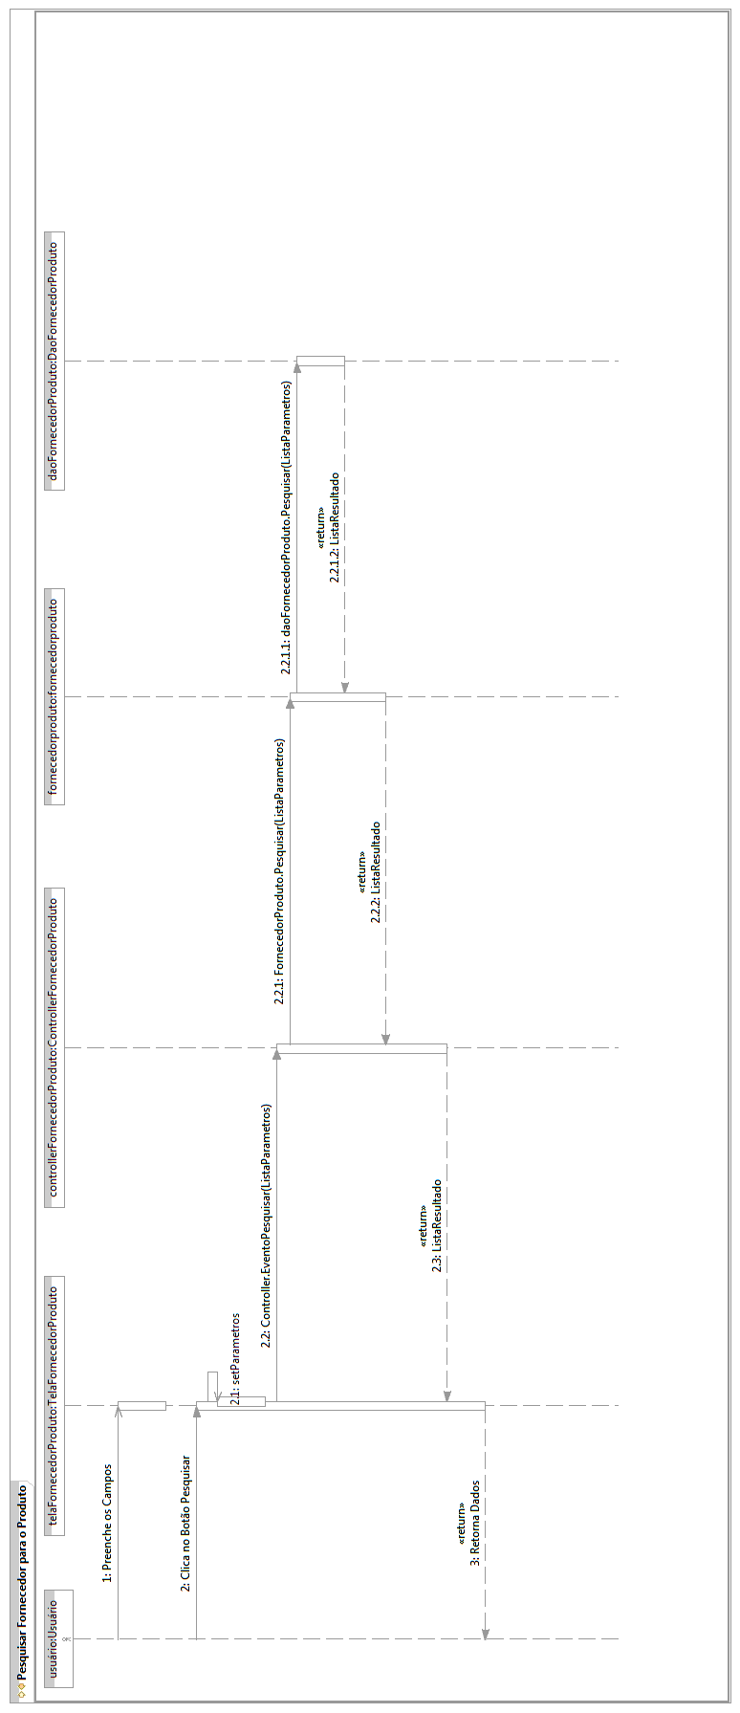
Fluxo Principal – Caso de Uso Pesquisar Motivo

[Each use case in the project has a unique identifier. Typically this reference is held in a database and used to cross-reference the use case against other requirements, such as those that might arise out of test plan.]
[The name is an active verb phrase, the goal of the primary actor, and something that the system can deliver to the primary actor.
e.g. Purchase Item, Withdraw Cash, Transfer Funds, Maintain Curve Definition…]

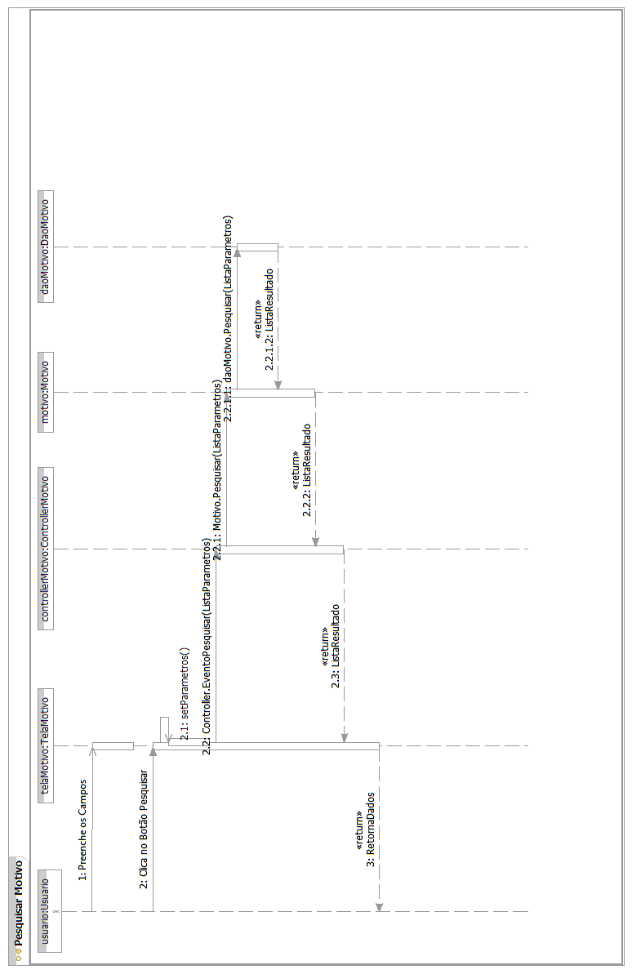

Fluxo Principal – Caso de Uso Pesquisar Ordem de Produção
[Each use case in the project has a unique identifier. Typically this reference is held in a database and used to cross-reference the use case against other requirements, such as those that might arise out of test plan.]
[The name is an active verb phrase, the goal of the primary actor, and something that the system can deliver to the primary actor.
e.g. Purchase Item, Withdraw Cash, Transfer Funds, Maintain Curve Definition…]

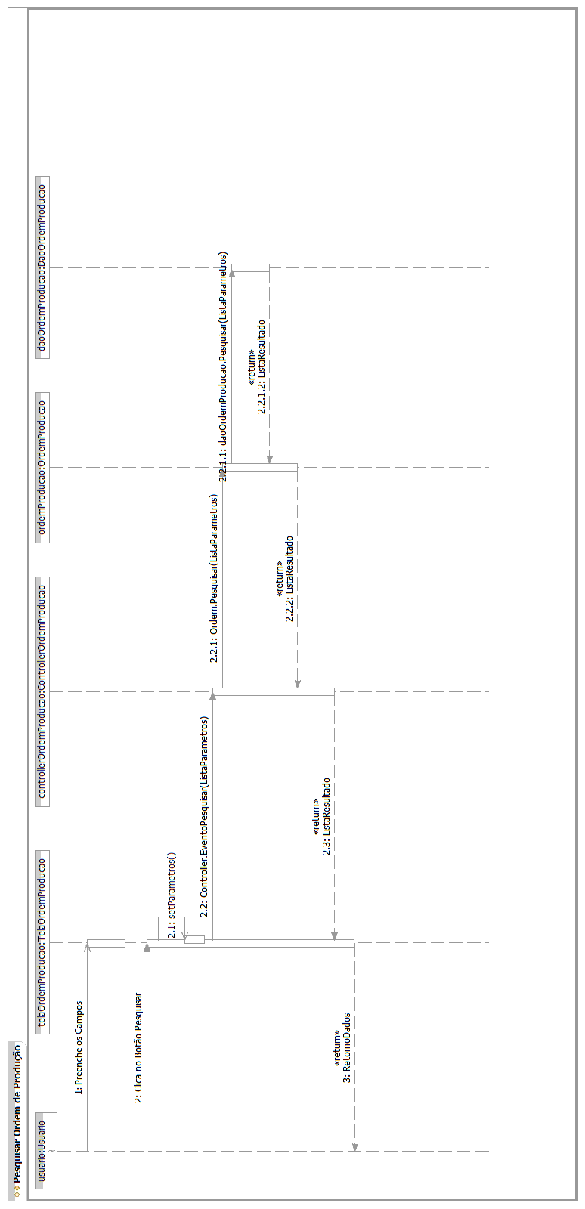

Fluxo Principal – Caso de Uso Pesquisar Pedido
[Each use case in the project has a unique identifier. Typically this reference is held in a database and used to cross-reference the use case against other requirements, such as those that might arise out of test plan.]
[The name is an active verb phrase, the goal of the primary actor, and something that the system can deliver to the primary actor.
e.g. Purchase Item, Withdraw Cash, Transfer Funds, Maintain Curve Definition…]
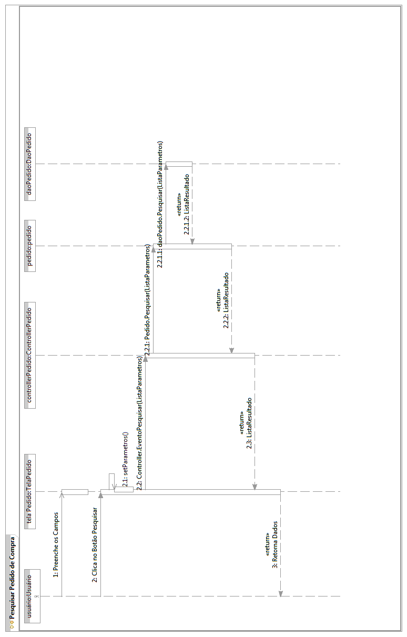
Fluxo Principal – Caso de Uso Pesquisar Perfil

[Each use case in the project has a unique identifier. Typically this reference is held in a database and used to cross-reference the use case against other requirements, such as those that might arise out of test plan.]
[The name is an active verb phrase, the goal of the primary actor, and something that the system can deliver to the primary actor.
e.g. Purchase Item, Withdraw Cash, Transfer Funds, Maintain Curve Definition…]
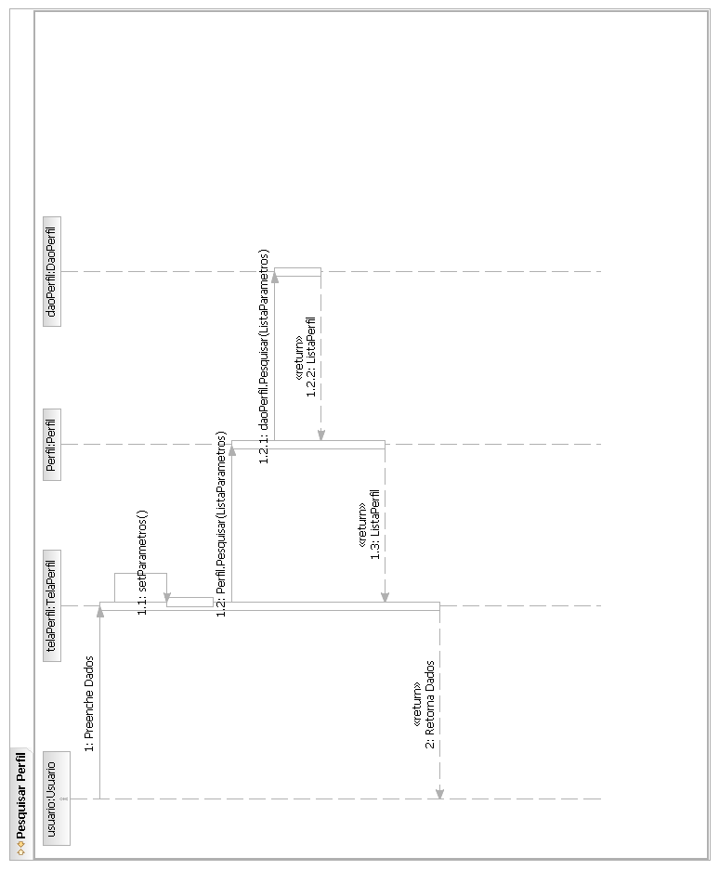
Fluxo Principal – Caso de Uso Pesquisar Produto

[Each use case in the project has a unique identifier. Typically this reference is held in a database and used to cross-reference the use case against other requirements, such as those that might arise out of test plan.]
[The name is an active verb phrase, the goal of the primary actor, and something that the system can deliver to the primary actor.
e.g. Purchase Item, Withdraw Cash, Transfer Funds, Maintain Curve Definition…]

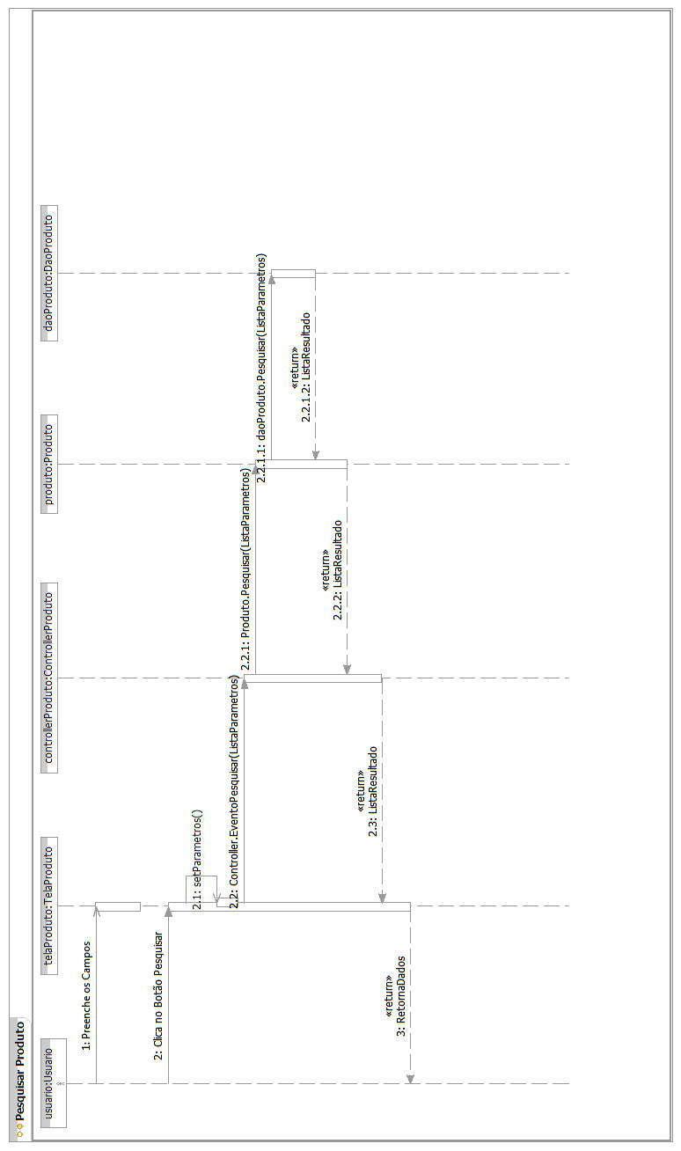

Fluxo Principal – Caso de Uso Pesquisar Refeição
[Each use case in the project has a unique identifier. Typically this reference is held in a database and used to cross-reference the use case against other requirements, such as those that might arise out of test plan.]
[The name is an active verb phrase, the goal of the primary actor, and something that the system can deliver to the primary actor.
e.g. Purchase Item, Withdraw Cash, Transfer Funds, Maintain Curve Definition…]

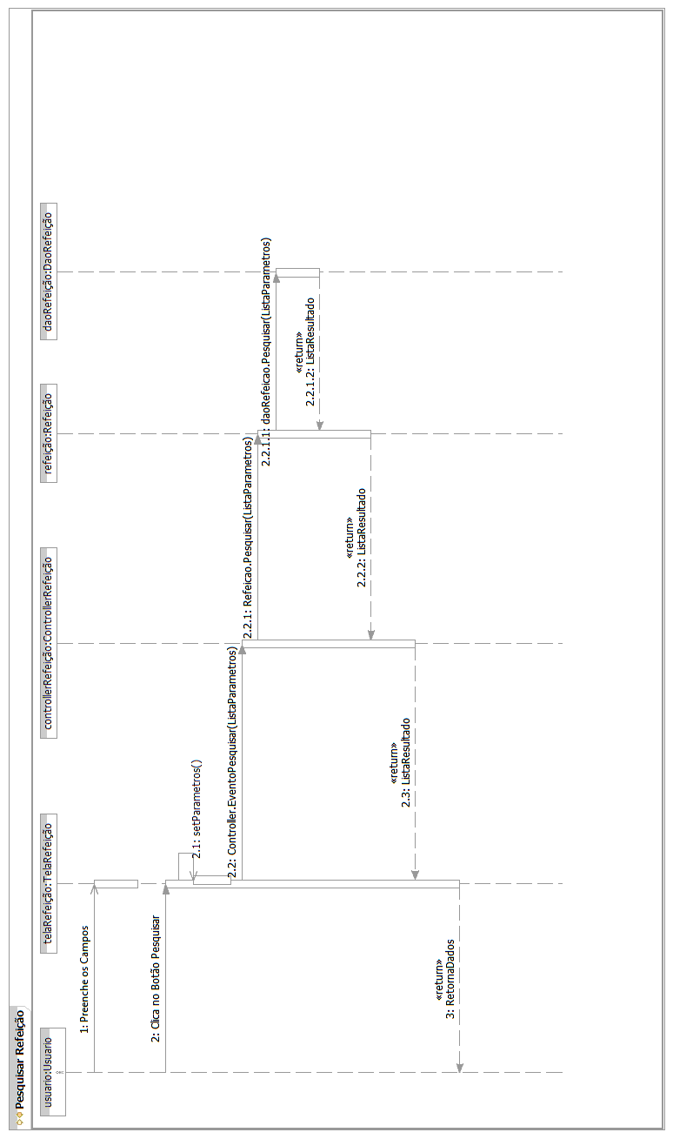

Fluxo Principal – Caso de Uso Pesquisar Tela
[Each use case in the project has a unique identifier. Typically this reference is held in a database and used to cross-reference the use case against other requirements, such as those that might arise out of test plan.]
[The name is an active verb phrase, the goal of the primary actor, and something that the system can deliver to the primary actor.
e.g. Purchase Item, Withdraw Cash, Transfer Funds, Maintain Curve Definition…]

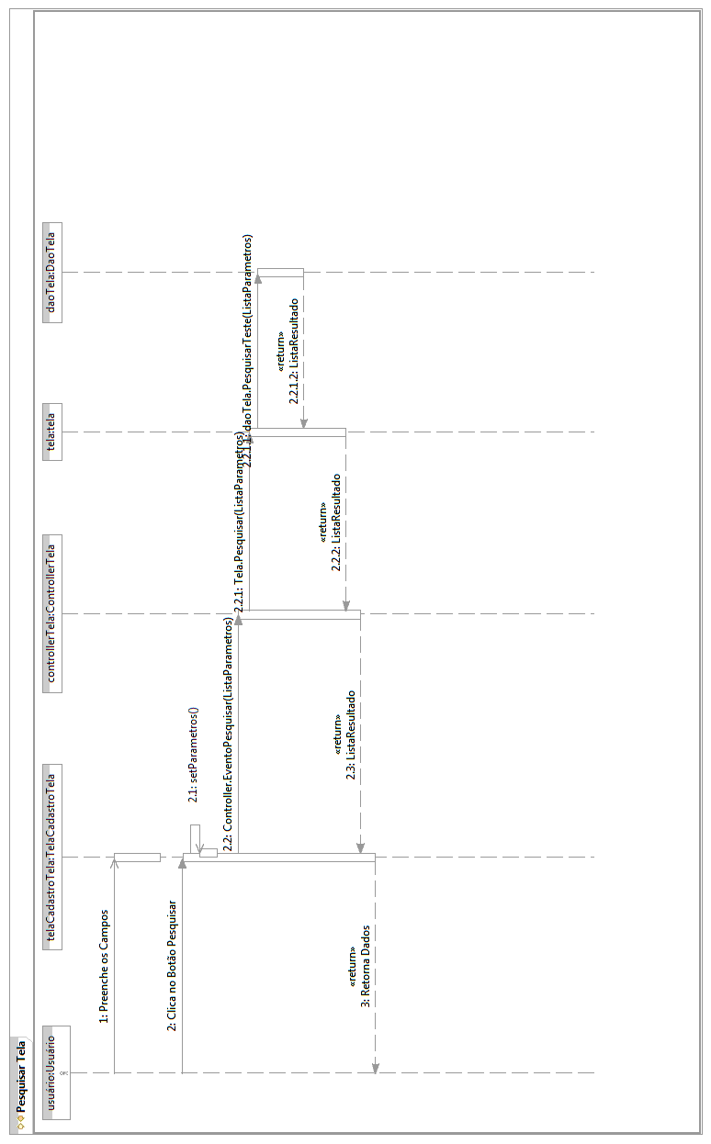

Fluxo Principal – Caso de Uso Pesquisar Unidade de Medida
[Each use case in the project has a unique identifier. Typically this reference is held in a database and used to cross-reference the use case against other requirements, such as those that might arise out of test plan.]
[The name is an active verb phrase, the goal of the primary actor, and something that the system can deliver to the primary actor.
e.g. Purchase Item, Withdraw Cash, Transfer Funds, Maintain Curve Definition…]

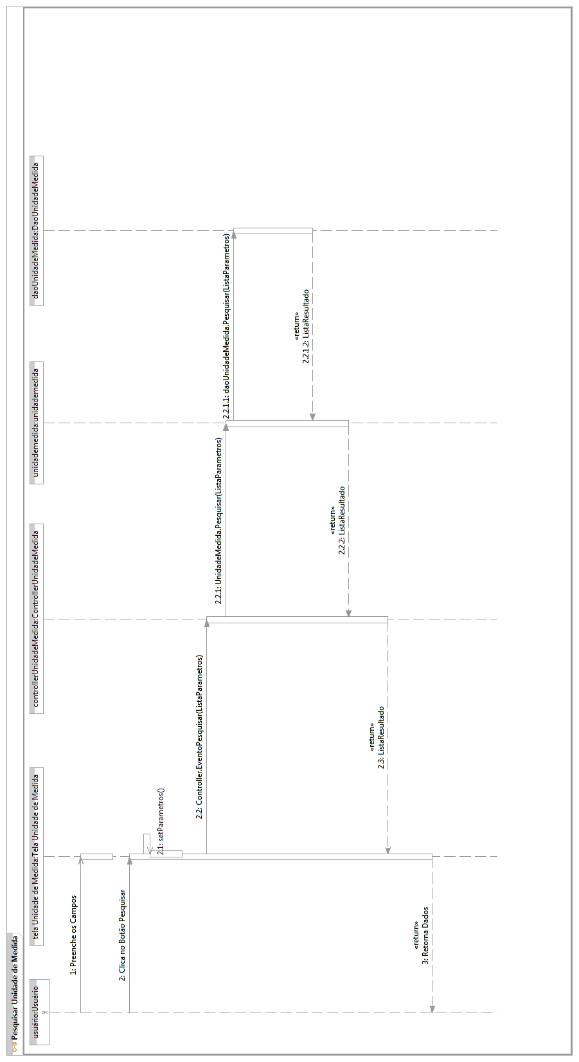

Fluxo Principal – Caso de Uso Pesquisar Usuário
[Each use case in the project has a unique identifier. Typically this reference is held in a database and used to cross-reference the use case against other requirements, such as those that might arise out of test plan.]
[The name is an active verb phrase, the goal of the primary actor, and something that the system can deliver to the primary actor.
e.g. Purchase Item, Withdraw Cash, Transfer Funds, Maintain Curve Definition…]

